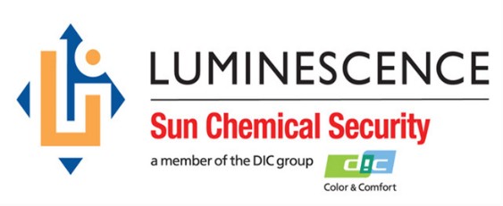

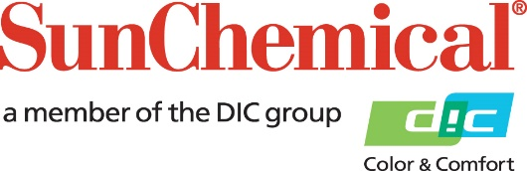



**PR Contacts:**

Ellie Martin, AD Communications

+44 1372 460 552

emartin@adcomms.co.uk

**Sun Chemical Security to showcase new range of products at African Currency Forum**

**WEXHAM SPRINGS, UK** – 30 August 2018 – Sun Chemical Security, a [newly formed division of Sun Chemical](http://www.sunchemical.com/paul-cooper-appointed-to-lead-sun-chemical-security-division/) focusing specifically on security printing, will use the upcoming African Currency Forum from 2nd to 5th September 2018 in Victoria Falls, Zimbabwe, to launch its latest portfolio of infrared inks for banknote printing. This includes new products all with infrared capabilities for current and future sensor and validation technology.

The products are a combination of infrared visible and invisible inks for banknote validation. The pigments have been developed to include specific properties within the infrared pigment that can be utilised with bill validators to ensure banknotes are more secure during transactions when used with third party machines.

The spectral properties of the new products mean that they work with current optical sensor technology as well as next generation, so when banks look to update their currency, due to advances in counterfeiting, or a new design, by using this latest range from Sun Chemical Security, the notes will be protected.

The pigments used within the products themselves are fairly light, which means that there is a greater colour gamut available to the banknote designer. They also have a very low concentration so can be incorporated into any offset ink, giving designers the flexibility for the final design.

Stefaan D’hoore, Business Development Director, Northern Europe, Sun Chemical comments: “These latest products in our Security division demonstrate that we are innovating and bringing new products to the market following our acquisition of Luminescence, earlier this year. The advantage for banks and printers using this technology is that the existing currency can be updated today with no changes required to the current validation systems. However, the infrared pigment can also be used with new, more complex sensor technology in the future, so when new validation software is available, manufacturers can integrate this into their upgraded systems.”

Visitors to the African Currency Forum can speak with the Sun Chemical Security team about the new range of products and see how they can upgrade their existing ink systems to future-proof their currency.

For more information on Sun Chemical Security, visit us at stand A8 at the African Currency Forum.

ENDS

**About Sun Chemical**

Sun Chemical, a member of the DIC group, is a leading producer of printing inks, coatings and supplies, pigments, polymers, liquid compounds, solid compounds, and application materials. Together with DIC, Sun Chemical has annual sales of more than $7.5 billion and over 20,000 employees supporting customers around the world.

Sun Chemical Corporation is a subsidiary of Sun Chemical Group Coöperatief U.A., the Netherlands, and is headquartered in Parsippany, New Jersey, U.S.A. For more information, please visit the Web site at [www.sunchemical.com](http://www.sunchemical.com).

cid:image004.png@01D2A73F.FCA42600