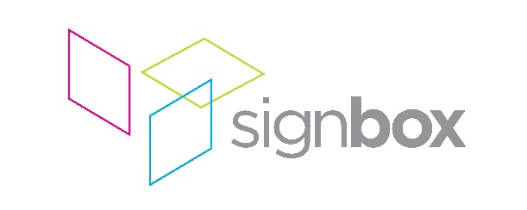

Press release

18th September 2017

Signbox delivers high spec wall graphics and glazing manifestations for new Alpha Bank London office

When Alpha Bank – one of Greece’s largest financial institutions – moved its offices from Canon Street to King William Street in the City of London, it commissioned Resonate Architects to transform its new space into one that exuded quality and delivered an amazing client experience – with added detail that represented its identity, ethos and Greek heritage. Having successfully worked with Signbox on many previous occasions, Resonate Architects turned to them to help to bring this project together, with main contractor Parkeray, awarding Signbox the contract to produce and install graphics for a feature wall in the staff break-out area, glazing manifestations throughout the office area, and bespoke signage for six meeting rooms.

Resonate and Signbox began collaboration on this project in January 2017, with the architects showing Signbox examples and ideas that Signbox was ultimately able to turn into reality. All elements of the project were installed on schedule in July 2017.

The finishes schedule provided by the client specified a particular tone of bronze and, for the feature wall in the break-out area, Signbox was able to colour match this to a 3M Di-Noc film, PA-039. Alpha Bank logos were precision cut on Signbox’s Zund S3 plotter and applied directly to a painted wall with a low-tack application tape. The end result is a striking feature wall that reinforces the bank’s brand, while also providing an attractive space for staff to unwind.

Glazing manifestations throughout the client meeting and general office areas totalled over 100 square metres of optically clear, scratch-resistant polyester film, UV printed by Signbox on their Durst P10-160. The challenge was to provide a bronze toned graphic with a fading percentage of background white ink, giving privacy to the meeting rooms as the opacity fades out, both up and down, from 60% at the centre. Detailed prototyping established the desired effect, with Signbox working closely with the Resonate team from a very early stage in the design process. The iconic Greek style of the graphic was designed by Signbox in response to a specific brief from the architects. The graphics are visible from inside and outside the meeting rooms’ glass walls.

The same graphic style employed in the meeting rooms was also applied to backlit glass either side of the reception desk. This required close collaboration with the joinery contractors and printing a white translucent backing film. Further glass manifestation work included the Alpha Bank logo applied to glass behind the reception desk with 3M Dusted Crystal film, reinforcing the bank’s brand to visitors and making a powerful first impression.

Finally, Signbox also created and delivered bespoke meeting room signs, printed on matt acrylic to precisely match the colour of the door handles. Machine engineered in-house, these signs slide across to indicate when the room is occupied. Across all elements of the project, Signbox delivered a quality finish that compliments the very high spec achieved throughout the wider refurbishment.

Says Signbox Managing Director Mark Bartlett: “We are delighted to have delivered on all of the challenging elements of this project to the client’s satisfaction, keeping on brand, communicating the client’s heritage and identity and maintaining an ultra-high standard of quality throughout. Alpha Bank now has a new City of London office to make the best possible impression on visitors and to provide an excellent working environment for its staff. We are also pleased to have had the opportunity to successfully partner Resonate on yet another project. We look forward to working with them on many more occasions in the future.”

ENDS

About Signbox
UK-based Signbox is a leading signage specialist with over 30 years’ industry experience. With intelligent design and application, the company consistently delivers award-winning visual communication strategies via traditional and pioneering signage methods across a number of market sectors, including corporate, education, healthcare, retail, hotel and leisure.

With a proven formula based on contemporary design, technical innovation and engineering excellence, Signbox’s holistic approach continues to put the company at the forefront of architectural signage. Sourcing and implementing cutting edge technologies and high quality sustainable materials, the company is renowned for delivering powerful interior and exterior signage projects for a diverse range of global brands in the UK, Europe, the Americas and the Far East – all of which are compliant, future-proof and visually arresting.

From concept to delivery, Signbox’s design team and installation specialists can create and execute bespoke signage installations from an eclectic range of high-end solutions and services that enable a brand to express itself in any environment.

Beyond traditional signage applications, the company’s service offering includes fabricated external structures, digitally printed glazing manifestations and wallpapers; way finding signage, digital signage, LED infused glass structures, contemporary name plates, interactive print via Near Field Communication (NFC) and signposting, among many others.

For further information, please visit: www.signbox.co.uk

For more information, please contact:

Daniel Porter
AD Communications Signbox
+44 (0)1372 464470 +44 (0)1784 438688
dporter@adcomms.co.uk sales@signbox.co.uk

