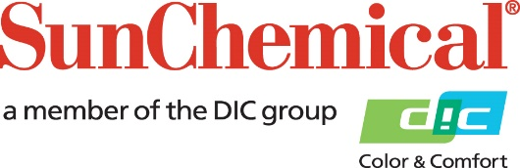



**PR Contacts:**

Lynn Campbell, Sun Chemical Matt Parry, Eric Mower + Associates

+1 973 404 6159 +1 315 413 4318

lynn.campbell@sunchemical.com [mparry@mower.com](mailto:mparry@mower.com)

**Sun Chemical Acquires C.T.LAY to Expand Portfolio for Plastic and Security Cards**

**PARSIPPANY, N.J., USA** – 22 January 2018 –Sun Chemical and its parent company, DIC Corporation, have acquired C.T.LAY S.R.L.

Based in Modena, Italy, C.T.LAY is a global leader in pre-laid overlays, pre-patched holograms and, through its joint-venture branch 4PLATE, experienced in lamination plates and sophisticated lamination plates with security elements and plasma coatings.

“The strategic acquisition of C.T.LAY will enable Sun Chemical to better serve its customers around the world,” said Mehran Yazdani, President, Sun Chemical Advanced Materials. “The broad range of technologies and services provided by C.T.LAY and 4PLATE will further strengthen Sun Chemical’s portfolio of magnetic tapes, screen and security inks, and electronic materials for plastic and security ID cards.”

“The integration of C.T.LAY into Sun Chemical Advanced Materials represents an exceptional opportunity to access worldwide card manufacturers as well as national printing houses,” said Alberto Chemelli and Lionel Tissier, co-founders of C.T.LAY.

C.T.LAY provides its industry-leading technologies to more than 70 countries worldwide. Over 500 million cards are produced annually with its stripe overlays as well as millions of governmental documents with its patch sheets. In order to grant the confidentiality and reliability required for governmental applications, C.T.LAY has earned various certifications, including CWA 15374:2008, ISO 14298:2013 and ISO 9001:2015.

With its acquisition of C.T.LAY, Sun Chemical now offers one of the most technologically-advanced product portfolios for the plastic and security cards market, including expanded manufacturing capabilities, technical service departments and sales teams to better serve its customers worldwide.

ENDS

**About Sun Chemical**

Sun Chemical, a member of the DIC group, is a leading producer of printing inks, coatings and supplies, pigments, polymers, liquid compounds, solid compounds, and application materials. Together with DIC, Sun Chemical has annual sales of more than $7.5 billion and over 20,000 employees supporting customers around the world.

Sun Chemical Corporation is a subsidiary of Sun Chemical Group Coöperatief U.A., the Netherlands, and is headquartered in Parsippany, New Jersey, U.S.A. For more information, please visit the Web site at [www.sunchemical.com](http://www.sunchemical.com).

cid:image004.png@01D2A73F.FCA42600