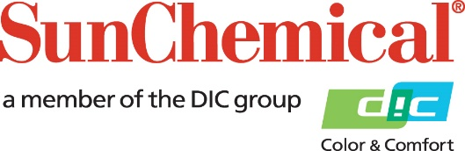



**PR Contacts:**

Matt Parry, Eric Mower + Associates

+1 315 413 4318

[mparry@mower.com](mailto:mparry@mower.com)

Sun Chemical and DIC Corporation to Increase Production Capacity of DAILUBE® Extreme Pressure Additives at Kashima Plant

**PARSIPPANY, N.J., U.S.A.** – 9 April 2018 – Beginning in April 2018, Sun Chemical and its parent company, DIC Corporation, will increase the production capacity of its **DAILUBE®** extreme pressure additives by 6,000 tons per annum at its eco-friendly plant in Kashima, Japan.

The move will better serve customers around the globe as well as promote and deliver its trusted and market leading sulfurized extreme pressure additives into new and existing markets.

Optimised for metalworking fluids used in cutting, forming and rolling, DAILUBE extreme pressure additives are light in colour, low odour and available in a range of chemistries, including olefin, lard, vegetable, ester and fatty acid.

Opened in 1972, the 600,000-square meter Kashima plant is the ideal location for capacity expansion due to its dedication to eco-friendly production processes, award-winning achievements and technological legacy. Along with extreme pressure sulfur additives, the facility produces organic pigments, bases for inks, metal carboxylates and polyphenylene sulfide (PPS) resins.

To reduce environmental impact, the Kashima plant utilises steam generation facilities, biomass boilers, solar panels and windmills to power the majority of its production processes. The facility has received various certifications and honours related to quality management, hygiene and safety and serves as a keystone to Sun Chemical and DIC Corporation’s commitment to quality, innovation and environmental responsibility.

ENDS

**About Sun Chemical**

Sun Chemical, a member of the DIC group, is a leading producer of printing inks, coatings and supplies, pigments, polymers, liquid compounds, solid compounds, and application materials. Together with DIC, Sun Chemical has annual sales of more than $7.5 billion and over 20,000 employees supporting customers around the world.

Sun Chemical Corporation is a subsidiary of Sun Chemical Group Coöperatief U.A., the Netherlands, and is headquartered in Parsippany, New Jersey, U.S.A. For more information, please visit our website at [www.sunchemical.com](BLOCKED::http://www.sunchemical.com/).

