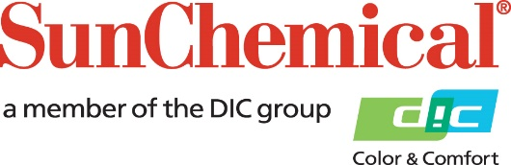



**PR Contacts:**

Lynn Campbell, Sun Chemical Matt Parry, Eric Mower + Associates

+1 973 404 6159 +1 315 413 4318

lynn.campbell@sunchemical.com [mparry@mower.com](mailto:mparry@mower.com)

**Sun Chemical and DIC Corporation Acquire Luminescence Holdings Ltd.**

**PARSIPPANY, N.J., USA** – 7 February 2018 – Sun Chemical and its parent company, DIC Corporation, have acquired Luminescence Holdings Ltd., a manufacturer of currency, tax stamp, passports, ID cards, secure documents and brand protection inks for the security market.

With the acquisition of the United Kingdom-based company, Sun Chemical will increase its market share in the securities market. By combining Luminescence’s portfolio of products with Sun Chemical’s global reach, customers will benefit from a new truly global player. The acquisition creates an enormous growth platform for Sun Chemical in the $2.7 billion security ink market.

“Luminescence has a fantastic reputation in the security market for technology and service,” said Felipe Mellado, Chief Marketing Officer and Board Member. “Sun Chemical has the world’s largest research and development capabilities in the ink marketplace. What these two companies bring together is a truly exciting global supplier that will further strengthen our service to customers.”

ENDS

**About Sun Chemical**

Sun Chemical, a member of the DIC group, is a leading producer of printing inks, coatings and supplies, pigments, polymers, liquid compounds, solid compounds, and application materials. Together with DIC, Sun Chemical has annual sales of more than $7.5 billion and over 20,000 employees supporting customers around the world.

Sun Chemical Corporation is a subsidiary of Sun Chemical Group Coöperatief U.A., the Netherlands, and is headquartered in Parsippany, New Jersey, U.S.A. For more information, please visit the Web site at [www.sunchemical.com](http://www.sunchemical.com).

cid:image004.png@01D2A73F.FCA42600