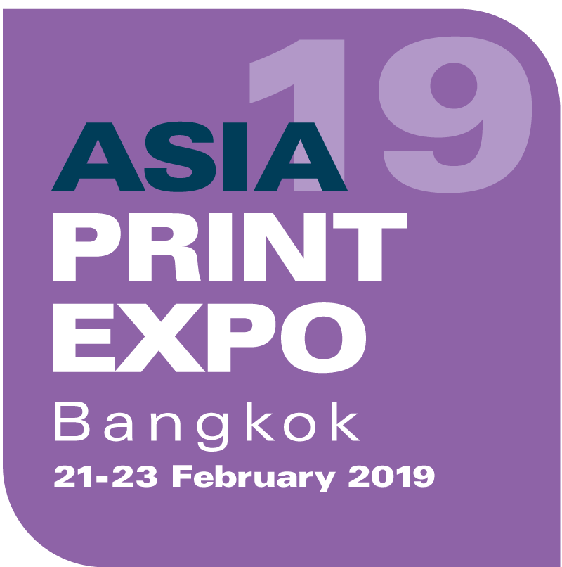
PRESS RELEASE
18 February 2019

EXHIBITORS ANNOUNCE PRODUCT HIGHLIGHTS AHEAD OF ASIA PRINT EXPO 2019

Asia Print Expo, the ASEAN region’s premier event for speciality print, takes place from 21 to 23 February 2019 at the BITEC Exhibition Centre in Bangkok, Thailand and will be the number one destination for ASEAN print service providers (PSPs) and sign-makers looking for the latest wide format technology.

With just under one week to go until the exhibition doors open, exhibitors are publicising what they will be demonstrating at the event. With 80 companies confirmed to exhibit, local and international PSPs will have a whole host of technology to discover, with some exclusive products being shown for the first time in Thailand.

Exhibitor highlights include:
- Best In Ground Co., Ltd (stand D20) will debut the Massivit 1500 3D printer by Massivit 3D for the first time in Thailand. The printer is a mid-entry-level industrial 3D printer that can print models up to 1.5m tall, 1.5m wide and 1.2m in depth. It is a fast 3D printer that uses Massivit 3D’s own proprietary GDP technology and is suitable for a range of markets.
- Chaiyaboon Brothers Co., Ltd (stand C11) will present Direct Color Systems’ UV LED printer, which features the TEXTUR3D™ printing process that uses one ink type to print on a variety of substrates including plastic, metal, wood and acrylic.
- Inkcups (stand A15) will feature live demonstrations on its stand of its Brite ICN 2200PS and ICN 2200LI-2P pad printers. ICN 2200PS produces high quality one- and two-colour prints on t-shirts, while ICN 2200LI-2P is a high-speed printer for printing on shoe insoles. Inkcups will also host a live plate-etching demonstration on its laser plate-making system, the ColbaltONE, which boasts fibre laser technology able to precisely etch spot sizes down to 50 microns for over 30,000 impressions.
- Technology 2004 Co., Ltd (stand D10) is a Thai importer and distributer specialising in creating, printing and cutting designs to suit PSPs’ needs in packaging, signage and textile. At Asia Print Expo, Technology 2004 will show its latest range of large format inkjet printers, cutters, plotters, laser cutting and engraving machines.
- Epson Thailand (stand E10) will showcase its printing technology for the textile and outdoor advertising industries. Epson Thailand will unveil its advertising signage printers, the Epson SureColor S-Series and Epson SureColor B-Series, which can print products for both indoor and outdoor applications. Epson will also present its SureColor F-Series for textile printing to demonstrate the production process from pattern printing to the finished product, including pillows, scarves, t-shirts and bags.

The inaugural Print Make Wear Asia will also take place at Asia Print Expo, which is sponsored by Easiway Systems, Vastex and PSI Marketing.

Highlights from the sponsors include:
- Vastex will showcase its manual screen printing machine, which requires fewer operators resulting in lower overhead costs as well as a dryer and flash unit
- Gildan will present its printable garments, which will be printed live during the exhibition
- Easiway will demonstrate how 3-minute stencil reclaiming can be made possible by the Easiway SUPRA, which reduces pre-press staff and makes the most of mesh fabrics.

In addition, visitors can take advantage of the other free-to-attend visitor features, including the Wrap Masters Asia competition, where 30 competitors will battle it out to be crowned the winner, and a packed programme in the FESPA conference theatre.

Visitors travelling by plane to Bangkok and still looking to book flights can book with FESPA’s official airline partner, Thai Airways, using code TG1902008. Booking can be accessed here: www.thaiairways.com/en/mice/index.page

For more information on Asia Print Expo 2019 visit: www.asiaprintexpo.com. For free entry, use code ASAM904 when registering.

ENDS
About FESPA
Founded in 1962, FESPA is a global federation of Associations for the screen printing, digital printing and textile printing community. FESPA’s dual aim is to promote screen printing and digital imaging and to share knowledge about screen and digital printing with its members across the world, helping them to grow their businesses and learn about the latest developments in their fast growing industries.

FESPA Profit for Purpose
The shareholders are the industry. FESPA has invested millions of Euros into the global printing community over the last seven years, supporting the growth of the market. For more information visit www.fespa.com

FESPA Print Census
The FESPA Print Census is a global research project to understand the wide format, screen and digital print community. It is the largest data gathering project of its kind.

Forthcoming FESPA events include:
- Asia Print Expo 2019, 21-23 February 2019, BITEC Exhibition Centre, Bangkok, Thailand
- FESPA Brasil, 20-23 March 2019, Expo Center Norte, São Paulo, Brazil
- FESPA Global Print Expo, 14-17 May 2019, Messe München, Munich, Germany
- European Sign Expo, 14-17 May 2019, Messe München, Munich, Germany
- FESPA Mexico, 22-24 August 2019, Centro Citibanamex, Mexico City, Mexico
- FESPA Africa, 11-13 September 2019, Gallagher Convention Centre, Johannesburg, South Africa
- FESPA China, 8-10 November 2019, Canton Fair Complex, Guangzhou, China
- FESPA Global Print Expo, 24-27 March 2020, Fiera de Madrid, Madrid, Spain

Issued on behalf of FESPA by AD Communications

For further information, please contact:

Ellie Martin Leighona Aris
AD Communications FESPA
Tel: + 44 (0) 1372 464470 Tel: +44 (0) 1737 228160
Email: emartin@adcomms.co.uk Email: leighona.aris@fespa.com
Website: www.adcomms.co.uk Website: www.fespa.com

