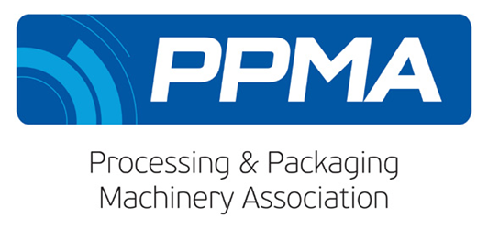
30th May 2018

Media Advisory
AD Communications appointed PR Agency for PPMA

Please be advised that the PPMA Group of Associations has appointed AD Communications as PR agency with responsibility for its corporate and PPMA Show accounts.

PPMA Show 2018
The PPMA Show 2018 will take place at the NEC, Birmingham from 25th – 27th September 2018.

All PR activity for the forthcoming PPMA Show 2018 is now being handled by AD Communications with immediate effect.

Show information will be issued shortly. In the meantime, if you have any queries or requests for additional editorial material for show preview features, please contact AD Communications.

Media contacts at AD Communications:
Helen Tolino Kirsty Jones
htolino@adcomms.co.uk kjones@adcomms.co.uk
Tel: +44 (0) 1372 464470 Tel: +44 (0) 1372 464470
Mobile: +44 (0) 7801 669746 Mobile: +44 (0) 7714 299520

Media Contacts at the PPMA:
Liezl Orenzo-Javier Zoe Crockett
Senior Marketing Executive Marketing Manager
liezl.orenzo-javier@ppma.co.uk zoe.crockett@ppma.co.uk
Tel: +44 (0) 20 8773 5522 Tel: +44 (0) 20 8773 5511

ENDS

About the PPMA
The PPMA is the UK's trade association for suppliers of processing and packaging machinery to the UK market and represents over 500 member and associate companies. Its principle objective is to promote sales of machinery, both at home and abroad, through various projects and services of mutual benefit to both members and their customers by providing free technical and machinery information and advice.

The PPMA Group of Associations includes BARA (British Automation and Robot Association) and UKIVA (UK Industrial Vision Association).

