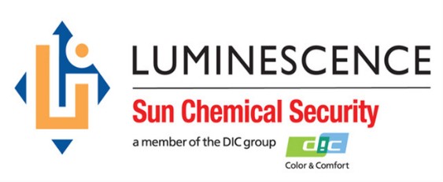

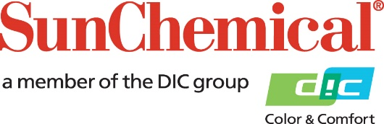



**PR Contacts:**

Ellie Martin, AD Communications

+44 1372 460 552

emartin@adcomms.co.uk

**Luminescence Sun Chemical Security to launch new range of machine-readable security inks at Dubai Currency Conference**

**WEXHAM SPRINGS, UK** – 2 April 2019 – Luminescence Sun Chemical Security, the security inks division of Sun Chemical, will use the forthcoming Currency Conference from 7 to 11 April 2019 in Dubai, UAE, to launch ASPECT, its new range of Level 2, machine-readable security inks for banknotes and to show the technology to the global banknote community for the first time.

Suitable for any country’s current cash-cycle infrastructure, ASPECT inks have distinctive infra-red signatures permitting broadband verification across a much wider range of the light spectrum, yet can also be read and verified by current authentication technologies, ranging from low-cost devices with limited automation to faster and bigger mid-market desk top solutions and even high-speed sorters used at commercial and central banks. Machine-readable inks play an integral part in the life of a banknote from its inception at the print factory during quality control through to destruction at the end of its life as an unfit banknote in the central bank.

Gerben van Wijk, Sales and Marketing Director, Luminescence Sun Chemical Security, comments: “Banknotes now interact with technology more than ever before as they circulate through the modern cash cycle, so it’s crucial that the appropriate levels of security are in place. Luminescence Sun Chemical Security understands this challenge and has dedicated significant resource and expertise to develop ASPECT, which will remain relevant through the life of the banknote by allowing for subsequent new issues or feature upgrades without any impact on cash-cycle verification technologies used now or in the future.”

Visitors to the Dubai Currency Conference can speak with the Luminescence Sun Chemical Security team about the new range of products and see how they can upgrade their existing features to future-proof their currency.

Nick Nugent, Technical Director, Luminescence Sun Chemical Security, will be presenting at the conference. His presentation will highlight the vital role that inks play in banknote security and the importance of collaboration between designers and technology providers, as one of the most challenging tasks for Central Banks, when deciding on a new banknote or series, is balancing the levels of security and selecting the right features across their family of banknotes.

For more information on Luminescence Sun Chemical Security, visit them at the Dubai Currency Conference.

ENDS

**Notes for Editors**

Caption for accompanying images: “Using ASPECT machine-readable banknote inks from Luminescence Sun Chemical Security, the hidden features on the sample document only become visible when viewed with a specific camera.”

**About Sun Chemical**

Sun Chemical, a member of the DIC group, is a leading producer of printing inks, coatings and supplies, pigments, polymers, liquid compounds, solid compounds, and application materials. Together with DIC, Sun Chemical has annual sales of more than $7.5 billion and over 20,000 employees supporting customers around the world.

Sun Chemical Corporation is a subsidiary of Sun Chemical Group Coöperatief U.A., the Netherlands, and is headquartered in Parsippany, New Jersey, U.S.A. For more information, please visit the website at [www.sunchemical.com](http://www.sunchemical.com).

cid:image004.png@01D2A73F.FCA42600