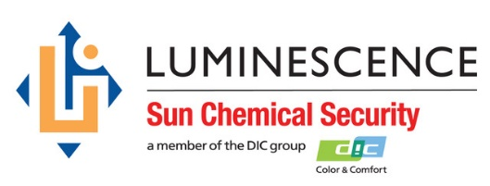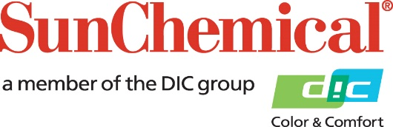



**PR Contacts:**

Ellie Martin/Greg Mills

AD Communications

+44 (0) 1372 464470

[emartin@adcomms.co.uk](mailto:emartin@adcomms.co.uk)

[gmills@adcomms.co.uk](mailto:gmills@adcomms.co.uk)

**Paul Cooper Appointed to Lead Sun Chemical Security Division**

**WEXHAM SPRINGS, UK – 28 August 2018** - Sun Chemical announces that the Sun Chemical Security division will operate under the brand name of Luminescence, the highly regarded manufacturer of security and brand protection inks that Sun Chemical acquired earlier this year. Suppliers of the very latest in security ink technological developments to governments and security printers in over 100 countries, Luminescence manufactures security inks suitable for offset, intaglio, flexo, gravure, screen, numbering and inkjet processes and security threads.

Luminescence will remain a standalone business, guaranteeing the confidentiality and strict protocols followed in the security inks business. This will be headed by Paul Cooper who has over 30 years’ experience in the security market. A key driver in the success of Luminescence, Cooper will now have the vast resources of Sun Chemical to provide a world class service on a global basis.

Specialising in customised, ink-based solutions for banknotes, tax stamps and secure documents, such as passports and ID cards, the new business offers customers an unsurpassed combination of technology, production and R&D capabilities, global reach and financial stability. This unique proposition, underpinned by the highest ethical standards, means that, for all security printers and central banks, Luminescence presents a world-class alternative to existing suppliers in the market. Recognising this, two of the top four global central banks have already demonstrated their confidence in Luminescence and Sun Chemical Security by engaging the division.

The business is headquartered in the UK, with R&D facilities in the UK, France and the USA and with secure, European bank accredited manufacturing sites in UK, France and the Netherlands. Further significant investments are planned to support the rapidly growing business.

Commenting on his appointment, Cooper says: “I’m delighted to have been entrusted with leading Sun Chemical Security and will ensure that the Luminescence philosophy of giving our customers the highest levels of innovation, security, discretion and confidentiality continues to be fundamental to our business approach. Previously Luminescence may have had a limited ability to scale operations to meet the needs of the largest printers and banks, just as Sun Chemical might not have had the technology to meet the demands of every printer and bank in the market. Together, however, in the new combined organisation, we now have the capabilities to satisfy the requirements of every security printer and central bank.”

Felipe Mellado, Chief Marketing Officer & Board Member, Sun Chemical adds: “With our broad range of capabilities and our vast experience, we’ve already proved that Sun Chemical can add significant value for customers in other print markets and are confident that Sun Chemical Security, led by Paul Cooper, can do the same by making security printing more productive and cost-effective. We’re 100 per cent committed to the security printing market and, with the combination of Luminescence’s proven technologies and Sun Chemical’s global reach, resources and R&D capability, we can provide the security printing industry with a highly competitive and innovative partner.”

For more information, visit: [www.sunchemicalsecurity.com](http://www.sunchemicalsecurity.com)

**About Sun Chemical**

Sun Chemical, a member of the DIC group, is a leading producer of printing inks, coatings and supplies, pigments, polymers, liquid compounds, solid compounds, and application materials. Together with DIC, Sun Chemical has annual sales of more than $7.5 billion and over 20,000 employees supporting customers around the world.

Sun Chemical Corporation is a subsidiary of Sun Chemical Group Coöperatief U.A., the Netherlands, and is headquartered in Parsippany, New Jersey, U.S.A. For more information, please visit the Web site at [www.sunchemical.com](http://www.sunchemical.com).

cid:image004.png@01D2A73F.FCA42600