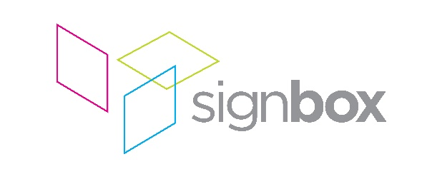
Press release

14th March 2019

Signbox raises the bar code with a show-stopping LED illumination installation at One Bartholomew

Signbox, the award-winning signage pioneer, has transformed a complex neon bar code wall art concept into a show-stopping LED illumination installation at One Bartholomew, an iconic new Grade A office building in Barts Square in the City of London.

Commissioned to deliver a CAT A signage project by architect, Sheppard Robson, on behalf of contractor, Mace Group, Signbox went on to devise a compelling solution for the architect’s ambitious bar code scheme that would create an exhilarating visual impact within the building’s vast, double-height reception space.

One Bartholomew is a 12-storey, 221,000 sq.ft office building with stunning views over Barts Square, St Pauls and the City skyline and is owned by property investor, Helical plc. Its ground floor is now dominated by the remarkable installation that spells out the building’s name in bar code and the commanding presence of its unique neon composition has led to a remarkable transformation for users and visitors of this cutting-edge space.

This was, however, to prove a demanding project, as Greg Bailey, Senior Project Manager at Signbox, revealed.

‘Creating a solution that would articulate the architect’s vision was not without its difficulties,’ he explained. ‘The complex cabling and environmental factors had initially seemed insurmountable but, after much collaboration and feasibility research, our team devised a solution that would enable us to interpret and execute the scheme to achieve the desired impact.

‘The project was not without its physical challenges either – the installation was huge, weighing in at almost a metric tonne and measuring 15,000 x 3,000mm overall. Maintaining the physical integrity of the unit along with the elaborate lighting and cable systems that would support it, meant we had to come up with a highly imaginative approach to both the manufacture and delivery of this project.’

The installation is suspended in front of a mechanically fixed stone wall cladding system and recessed lighting troughs were required to render the intricate LED cabling invisible. The lighting raft was also a substantial size – it was manufactured in aluminium in five, three-metre sections so it could be transported to the new building ready for assembly on site. The face elements of the bar code were fabricated from a specialist Perspex that would optimise the installation’s colour performance and impede any potential LED hotspots, while 3M translucent vinyls ensured the precise colour gradients could be achieved and present this ingeniously branded signage exercise to best effect.

Indeed, such has been the impact of the installation on this City space, it has fast-become a referenced landmark for visitors to One Bartholomew, and also to those in its immediate vicinity where the illuminated bar code is projected across the interior space – and out onto the streets outside.
For more information about this project, please read the case study.

ENDS

About Signbox
UK-based Signbox is a leading signage specialist with over 30 years’ industry experience. With intelligent design and application, the company consistently delivers award-winning visual communication strategies via traditional and pioneering signage methods across a number of market sectors, including corporate, education, healthcare, retail, hotel and leisure.

With a proven formula based on contemporary design, technical innovation and engineering excellence, Signbox’s holistic approach continues to put the company at the forefront of architectural signage. Sourcing and implementing cutting edge technologies and high quality sustainable materials, the company is renowned for delivering powerful interior and exterior signage projects for a diverse range of global brands in the UK, Europe, the Americas and the Far East – all of which are compliant, future-proof and visually arresting.

From concept to delivery, Signbox’s design team and installation specialists can create and execute bespoke signage installations from an eclectic range of high-end solutions and services that enable a brand to express itself in any environment.

Beyond traditional signage applications, the company’s service offering includes fabricated external structures, digitally printed glazing manifestations and wallpapers; way finding signage, digital signage, LED infused glass structures, contemporary name plates, interactive print via Near Field Communication (NFC) and signposting, among many others.

For further information, please visit: www.signbox.co.uk

For more information, please contact:

Daniel Porter Mark Bartlett
AD Communications Signbox
+44 (0)1372 464470 +44 (0)1784 497550
dporter@adcomms.co.uk Mark@signbox.co.uk

