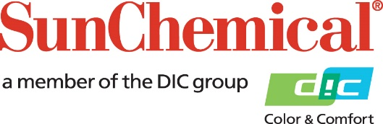

PR Contacts:
Ellie Bunce/Lucy O’Dea
AD Communications
+44 (0) 1372 464470
ebunce@adcomms.co.uk
lodea@adcomms.co.uk

Sun Chemical Acquires Flint Group’s European Publication Gravure Ink Business

Wexham Springs, UK – 5 August 2016 – Sun Chemical has announced its intention to acquire Flint Group’s European Publication Gravure Ink Business.

The acquisition will include the transfer of all products relating to Flint Group’s European publication gravure products and reflects Sun Chemical’s continued dedication to supporting this sector.

Felipe Mellado, Chief Marketing Officer and Board Member at Sun Chemical, comments: “Sun Chemical remains committed to all its publication businesses. The acquisition of Flint Group’s Publication Gravure Ink Business reaffirms our commitment to this sector and will enable us to further strengthen and enhance the performance of our own publication gravure plants. We pride ourselves on our high level of quality and customer service and – after completion of the transaction – will work alongside Flint Group to ensure a smooth and seamless transition of operations, ensuring customers are fully supported.”

Completion of the sale is still subject to customary closing conditions, including the approval of the competition authorities. Until such time as approval is granted, Sun Chemical and Flint Group will continue to manage their European publication gravure businesses independently without impact to customers, employees and suppliers.

For more information on Sun Chemical visit: www.sunchemical.com

ENDS
About Sun Chemical
Sun Chemical, a member of the DIC group, is a leading producer of printing inks, coatings and supplies, pigments, polymers, liquid compounds, solid compounds, and application materials. Together with DIC, Sun Chemical has annual sales of more than $7.5 billion and over 20,000 employees supporting customers around the world.
Sun Chemical Corporation is a subsidiary of Sun Chemical Group Coöperatief U.A., the Netherlands, and is headquartered in Parsippany, New Jersey, U.S.A. For more information, please visit our Web site at www.sunchemical.com.

