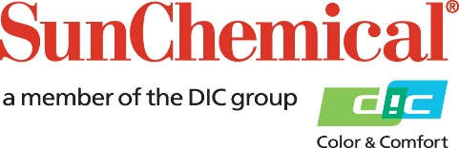

PR Contacts:
Ellie Martin/Greg Mills
AD Communications
+44 (0) 1372 464470
emartin@adcomms.co.uk
gmills@adcomms.co.uk

Sun Chemical to exhibit at Advanced Functional & Industrial Printing Conference 2019

Wexham Springs, UK – 13 February 2019: Sun Chemical will showcase its portfolio of inks for functional and industrial printing at ESMA’s Advanced Functional & Industrial Printing Conference (AFIP) 2019 on the 27th and 28th March 2019 at the Radisson Blu Scandinavia in Düsseldorf, Germany.

At the conference and table top exhibition, Sun Chemical will present its comprehensive range of inks and coatings for both screen and digital printing for the functional, industrial and high-tech markets.

Product highlights will include:

- SunHytek - A number of ink ranges formulated for use across numerous functional and industrial applications, such as membrane switch graphics, automotive applications, fascia panels and high performance marking. This includes heat and humidity-resistant ink solutions for high-tech, appliance panel and automotive applications, for which a combination of high visual impact and long term durability is required.
- SunTronic® - A range of advanced materials for various printed electronic applications. Offering enhanced conductivities and ultra-fine line printing, these state-of-the-art technologies combine with traditional graphic and digital inkjet printing to deliver material solutions for applications that add functionality in a number of industrial applications.

- SunJet – Sun Chemical’s global inkjet brand will present its most recent breakthrough ink chemistries and digital technologies for functional and industrial printing. SunJet will also demonstrate its ability to collaborate on development projects with OEM partners, system integrators and printhead manufacturers for current and future applications across a number of market sectors.

Members of the Sun Chemical and SunJet team will be available on the stand to discuss any of Sun Chemical’s technologies and solutions throughout the exhibition.

For more information, on Sun Chemical’s products for the functional and industrial markets visit, www.sunchemical.com or visit Sun Chemical at AFIP 2019.

ENDS

About Sun Chemical
Sun Chemical, a member of the DIC group, is a leading producer of printing inks, coatings and supplies, pigments, polymers, liquid compounds, solid compounds, and application materials. Together with DIC, Sun Chemical has annual sales of more than $7.5 billion and over 20,000 employees supporting customers around the world.
Sun Chemical Corporation is a subsidiary of Sun Chemical Group Coöperatief U.A., the Netherlands, and is headquartered in Parsippany, New Jersey, U.S.A. For more information, please visit our Web site at www.sunchemical.com

