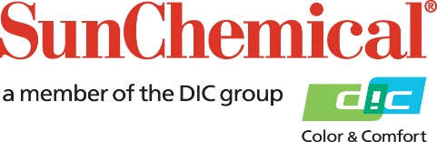

PR Contacts:
Ellie Martin/Greg Mills
AD Communications
+44 (0) 1372 464470
emartin@adcomms.co.uk
gmills@adcomms.co.uk

Sun Chemical Acquires PPG’s Metal Deco Ink Business

Wexham Springs, UK – 8 March 2018 –Sun Chemical has acquired the Metal Deco ink business of PPG, a US-based global supplier of paints, coatings and specialty materials. PPG, with a well consolidated portfolio, and Sun Chemical are both long standing players in the metal packaging industry.

Through the acquisition, which reflects Sun Chemical’s strategy to grow by acquiring businesses that complement areas of its existing operations, Sun Chemical will expand both its operational territories and its overall position in the global Metal Deco market. By combining PPG’s complementary portfolio of Metal Deco products with those of Sun Chemical, customers will benefit from further innovative solutions and what will be the widest ink portfolio in the metal decoration market.

Felipe Mellado, Chief Marketing Officer and Board Member at Sun Chemical, comments: “With changes in consumer tastes and lifestyles across the world driving increased demand for canned food and beverages, brands are constantly seeking new ways of decorating the metal packaging of their products to differentiate them from the competition. The acquisition of PPG’s Metal Deco ink business means that Sun Chemical will now be able to offer customers an enhanced range of Metal Deco solutions to help them achieve their marketing goals.”

For more information on Sun Chemical visit: www.sunchemical.com

ENDS

About Sun Chemical
Sun Chemical, a member of the DIC group, is a leading producer of printing inks, coatings and supplies, pigments, polymers, liquid compounds, solid compounds, and application materials. Together with DIC, Sun Chemical has annual sales of more than $7.5 billion and over 20,000 employees supporting customers around the world.
Sun Chemical Corporation is a subsidiary of Sun Chemical Group Coöperatief U.A., the Netherlands, and is headquartered in Parsippany, New Jersey, U.S.A. For more information, please visit our Web site at www.sunchemical.com

