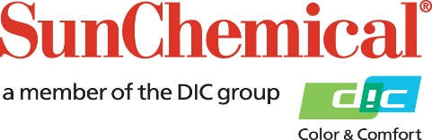



**PR Contacts:**

Ellie Martin/Greg Mills

AD Communications

+44 (0) 1372 464470

[emartin@adcomms.co.uk](mailto:emartin@adcomms.co.uk)

[gmills@adcomms.co.uk](mailto:gmills@adcomms.co.uk)

Sun Chemical launches class-leading UV LED offset inks

**Wexham Springs, UK** – **07 May 2019:** Sun Chemical has launched SunWave™ Lumina, a new range of high performance, UV LED curing sheetfed offset inks for commercial printing. Suitable for use on all sheetfed press types, the range offers class-leading lithographic performance, delivering fast makeready, highly stable printing with minimal wash-ups and excellent duct flow. This results in increased uptime for presses and increased productivity for commercial printers.

The SunWave Lumina range of inks is based on the latest highly engineered UV resin system and provides exceptionally fast and hard curing under UV LED and low energy mercury lamps for both single- and double-sided printing. SunWave Lumina is fully compliant with the latest EuPIA raw material guidelines.

While achieving outstanding levels of productivity, SunWave Lumina also delivers on print quality with excellent dot gain and high gloss and mechanical resistance and is designed for Process Standard Offset printing to ISO12647.

Jonathan Sexton, Marketing Manager, Energy Curing Products Europe, Sun Chemical, comments: “SunWave Lumina is a significant step forward for our portfolio of UV low-energy-curing offset inks. Not only does the range meet the market’s need for robust inks that maximize the uptime of sheetfed presses by minimizing the cleaning time required during printing, but, based on our own benchmarking and customer tests on various sheetfed presses, it delivers best-in-class performance.”

The new SunWave Lumina process ink range is immediately available initially in Europe from Sun Chemical.

ENDS

**About Sun Chemical**

Sun Chemical, a member of the DIC group, is a leading producer of printing inks, coatings and supplies, pigments, polymers, liquid compounds, solid compounds, and application materials. Together with DIC, Sun Chemical has annual sales of more than $7.5 billion and over 20,000 employees supporting customers around the world.

Sun Chemical Corporation is a subsidiary of Sun Chemical Group Coöperatief U.A., the Netherlands, and is headquartered in Parsippany, New Jersey, U.S.A. For more information, please visit our Web site at [www.sunchemical.com](BLOCKED::http://www.sunchemical.com/)