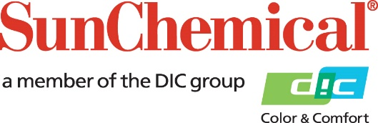

Sun Chemical PR Contacts:
Ellie Bunce/Greg Mills
AD Communications
+44 (0) 1372 464470
ebunce@adcomms.co.uk
gmills@adcomms.co.uk

Sun Chemical Receives ECO PASSPORT Certification for its SunTex Range of Digital Textile Inks

Midsomer Norton, UK, 8 May 2017: Sun Chemical’s digital textile ink range, SunTex, has achieved OEKO-TEX certification for its SunTex Sonata DTE ink series.

Achieving this certification means that SunTex Sonata DTE ink series can be used in sustainable textile production when used with certified textile substrates.

The ECO PASSPORT by OEKO-TEX is a comprehensive verification and certification system for textile chemicals, colorants and auxiliaries and is fully integrated with the two OEKO-TEX® certification systems for sustainable textile production (STeP by OEKO-TEX®) and product safety (STANDARD 100 by OEKO-TEX®).

Daniel Coelho, Sales Manager, Europe SunTex at Sun Chemical comments: “The OEKO-TEX Standard 100 certification is widely quoted in the textile industry. It certifies that interaction between the ink and fabric on the finished textile substrate, meets the OEKO-TEX 100 specification. When printers use SunTex Sonata DTE inks with a suitable textile fabric, they will have peace of mind that they are producing a sustainable product.

“This certification shows that our SunTex ink range does not contain any volatile ingredients and demonstrates that the ink and ink manufacturing process will allow printers to achieve OEKO-TEX 100 print certification so long as they themselves print with these inks using typical dye-sublimation transfer print papers, fabrics and finishing processes.”

SunTex will also be entered into the OEKO-TEX Buying Guide, which allows brands, retailers and manufacturers to source sustainable and safer chemical products.

Sun Chemical’s SunTex Sonata DTE ink series is a six colour dye sublimation transfer inkjet ink series, compatible with Epson DX 4-7 printheads. The ink series will be on display on stand D20, hall B5. FESPA 2017 from 8 – 12 May 2017 in Hamburg, Germany.

ENDS

About Sun Chemical
Sun Chemical, a member of the DIC group, is a leading producer of printing inks, coatings and supplies, pigments, polymers, liquid compounds, solid compounds, and application materials. Together with DIC,
Sun Chemical has annual sales of more than $7.5 billion and over 20,000 employees supporting customers around the world.
Sun Chemical Corporation is a subsidiary of Sun Chemical Group Coöperatief U.A., the Netherlands, and is headquartered in Parsippany, New Jersey, U.S.A. For more information, please visit our Web site at www.sunchemical.com.

