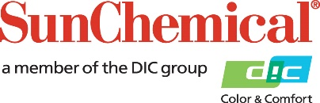

PR Contacts:
Heather Buchholz, Sun Chemical Matt Parry, Mower
+1 708 236 3779 +1 315 413 4318
Heather.buchholz@sunchemical.com mparry@mower.com

Sun Chemical to Increase Prices of Liquid Inks in Europe
PARSIPPANY, N.J., USA – 6 December 2018 – Sun Chemical will implement a new price increase affecting its solvent- and water-based liquid inks in Europe, effective 15 January 2019.

Costs have risen annually on a variety of key raw materials used to manufacture inks, including solvents, acrylic derivatives, organic pigments and polyols and isocyanates, which are the basic building blocks for numerous resins. Additionally, the ongoing initiatives in China to enforce tighter environmental regulations at chemical plants has resulted in ongoing supply disruptions.

“The increasing raw material costs continue at an unprecedented rate and require us to increase customer prices,” said Felipe Mellado, Chief Marketing Officer, Sun Chemical. “We will continue to work with our supply chain partners to manage and minimise the impact on our customers.”

ENDS

About Sun Chemical
Sun Chemical, a member of the DIC group, is a leading producer of printing inks, coatings and supplies, pigments, polymers, liquid compounds, solid compounds, and application materials. Together with DIC, Sun Chemical has annual sales of more than $7.5 billion and over 20,000 employees supporting customers around the world.

Sun Chemical Corporation is a subsidiary of Sun Chemical Group Coöperatief U.A., the Netherlands, and is headquartered in Parsippany, New Jersey, U.S.A. For more information, please visit our website at www.sunchemical.com.

