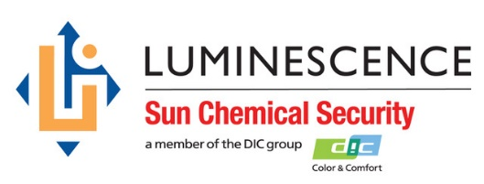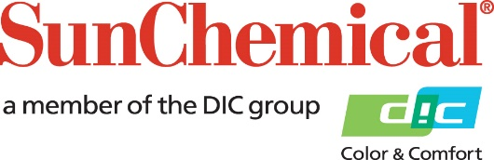



**PR Contacts:**

Ellie Martin/Greg Mills

AD Communications

+44 (0) 1372 464470

[emartin@adcomms.co.uk](mailto:emartin@adcomms.co.uk)

[gmills@adcomms.co.uk](mailto:gmills@adcomms.co.uk)

Luminescence Sun Chemical Security joins the International Currency Association

**4 September 2018, Wexham Springs, UK *–*** Luminescence Sun Chemical Security has become a member of the International Currency Association (ICA). A not-for-profit organisation that works to unify various suppliers within the international currency market, the ICA’s overall aim is to support and promote the role of currency worldwide. The ICA provides members with key market insight such as information on political and technical developments affecting the industry, while also supplying platforms for exchanges of knowledge, such as expert committees and industry gatherings on various topics.

Paul Cooper, President of Luminescence Sun Chemical Security comments “As a serious player within the industry, we’re delighted to be joining the ICA and are looking forward to playing an active role in helping to shape the future of the currency industry. By bringing together suppliers from all segments of the industry, the ICA fulfils an important role in establishing common standards and high quality training programmes that benefit the whole industry directly or indirectly. Recognising that the cash life cycle is a complex process that requires a collaborative approach by multiple parties, by joining the ICA, we hope to establish closer partnerships with other industry stakeholders to improve the efficiency of the process and to further the ICA’s promotion of the highest ethical standards across the industry.

He concludes: “Building on our participation in industry conferences and other associations, and as well as giving us access to unique material such as market studies and statistics, our membership of the ICA now gives us a greater voice in support of the industry and cements our position as a major supplier to the currency printing industry.”

ENDS

For more information, visit: [www.sunchemicalsecurity.com](http://www.sunchemicalsecurity.com)

**About Sun Chemical**

Sun Chemical, a member of the DIC group, is a leading producer of printing inks, coatings and supplies, pigments, polymers, liquid compounds, solid compounds, and application materials. Together with DIC, Sun Chemical has annual sales of more than $7.5 billion and over 20,000 employees supporting customers around the world.

Sun Chemical Corporation is a subsidiary of Sun Chemical Group Coöperatief U.A., the Netherlands, and is headquartered in Parsippany, New Jersey, U.S.A. For more information, please visit the Web site at [www.sunchemical.com](http://www.sunchemical.com).

cid:image004.png@01D2A73F.FCA42600