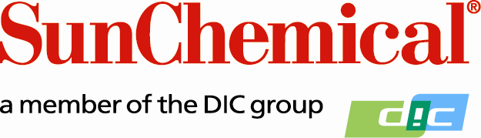

PR Contacts:
Ellie Martin/Greg Mills
AD Communications
+44 (0) 1372 460542
emartin@adcomms.co.uk
gmills@adcomms.co.uk

Sun Chemical to Demonstrate Latest UV Ink Solutions at IST UV Days 2019

Wexham Springs, UK – 09 May 2019: Sun Chemical will be exhibiting at IST Metz’s UV Days stand 42 in Nurtingen, Germany, between 13 and 16 May 2019. The event is the world’s largest in-house exhibition for optical systems, organised by one of the leading global suppliers of UV curing systems.

Sun Chemical will showcase its latest range of class-leading UV LED curing offset inks - SunWave™ Lumina. The fully EuPIA compliant inks are suitable for use on all sheetfed LED press types including those equipped with low energy mercury lamps and deliver leading lithographic performance that helps printers to achieve increased productivity.

Sun Chemical experts will also be available to discuss the company’s complete UV printing portfolio of EuPIA compliant products, featuring new migration-compliant LED offset and flexo inks and its complete product offering of UV inks and coatings for food and sensitive packaging and commercial print.

Commenting on Sun Chemical’s presence at the show, Jonathan Sexton, Marketing Manager, Energy Curing Products Europe, Sun Chemical says: “We are delighted to be exhibiting again at such a significant industry event. The popularity of the exhibition space demonstrates the growth within UV and LED technology and echoes the developments that are driving Sun Chemical’s product program. With our many years of expertise in the UV industry, we’re excited to take this opportunity to discuss our latest innovations.”

For more information on Sun Chemical and its solutions, please visit: www.sunchemical.com or stand 42 at IST Metz’s UV Days 2019.

ENDS

About Sun Chemical
Sun Chemical, a member of the DIC group, is a leading producer of printing inks, coatings and supplies, pigments, polymers, liquid compounds, solid compounds, and application materials. Together with DIC, Sun Chemical has annual sales of more than $7.5 billion and over 20,000 employees supporting customers around the world.

Sun Chemical Corporation is a subsidiary of Sun Chemical Group Coöperatief U.A., the Netherlands, and is headquartered in Parsippany, New Jersey, U.S.A. For more information, please visit our Website at www.sunchemical.com.

