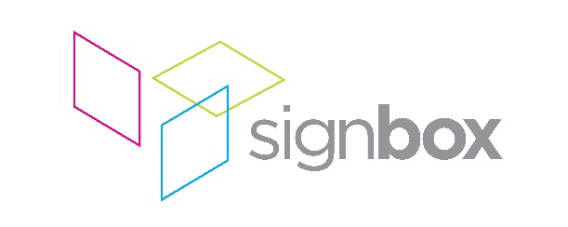

Press release

1st August 2017

Signbox delivers stunning brass-effect directory for prestigious London office building 12 Arthur Street

Signbox has supplied a bespoke tenant directory sign for the reception area at 12 Arthur Street, near London Bridge. Having won the opportunity with contractors Kingly Developments through a competitive tender process in January 2017, the work was completed in mid-June. The project formed a key part of the extensive reception and lift lobby refurbishment in this prestigious office building which currently lists Prudential and A.M. Best among its tenants.
Signbox manufactured the directory sign in-house on a Tekcel EXR router using 20mm thick acrylic and 6mm thick aluminium. The sign components were finished with a tarnished brass metal effect, a revolutionary process that applies a veneer of a metal coating to the surface and gives the look and feel of solid metal. This Metall-FX manufacturing process involves artisan hand-finishing, polishing and painting multiple layers to achieve the appearance of aged brass, matching other architectural details in the build. The surface edges of the sign were bevelled with a pencil round router bit and sanded to a specific grit finish to achieve the optimum surface. Though it was time-consuming, the weight and cost savings over traditional brass fabrication were considerable.
“The architects on the project, Morrow + Lorraine, had originally requested a solid metal fabrication that would have been very expensive to produce,” explains Signbox managing director Mark Bartlett. “With our extensive experience of manufacturing techniques, we were able to value engineer the design, presenting an alternative proposal which offered significant cost savings to the client. We also worked closely with the specialist concrete cladding contractor – Graphic Relief – in order to facilitate a first fix of the support channels to secure the directory to the wall behind reception.”
“We have worked with Kingly Developments on a number of high-profile projects over the years,” Bartlett adds. “We were delighted to team up with them again on this project and, together with the architects and other specialist contractors, deliver a finished product that met all of the client’s expectations, while also coming in under budget.”
“Working with Signbox on the brass effect tenant directory for 12 Arthur Street has been a real success,” says Daniel Hall, Associate at Morrow + Lorraine Architects. “We have developed a good rapport through the period of design development, and have been impressed with their ability to advise on finishes and manufacturing processes that respond to the brief, ensuring the product was delivered on programme and within budget. We would be happy to work with Signbox again on future collaborations.”

ENDS

About Signbox
UK-based Signbox is a leading signage specialist with over 30 years’ industry experience. With intelligent design and application, the company consistently delivers award-winning visual communication strategies via traditional and pioneering signage methods across a number of market sectors, including corporate, education, healthcare, retail, hotel and leisure.

With a proven formula based on contemporary design, technical innovation and engineering excellence, Signbox’s holistic approach continues to put the company at the forefront of architectural signage. Sourcing and implementing cutting edge technologies and high quality sustainable materials, the company is renowned for delivering powerful interior and exterior signage projects for a diverse range of global brands in the UK, Europe, the Americas and the Far East – all of which are compliant, future-proof and visually arresting.

From concept to delivery, Signbox’s design team and installation specialists can create and execute bespoke signage installations from an eclectic range of high-end solutions and services that enable a brand to express itself in any environment.

Beyond traditional signage applications, the company’s service offering includes fabricated external structures, digitally printed glazing manifestations and wallpapers; way finding signage, digital signage, LED infused glass structures, contemporary name plates, interactive print via Near Field Communication (NFC) and signposting, among many others.

For further information, please visit: www.signbox.co.uk

For more information, please contact:

Daniel Porter Mark Bartlett
AD Communications Signbox
+44 (0)1372 464470 +44 (0)1784 497550
dporter@adcomms.co.uk Mark@signbox.co.uk

