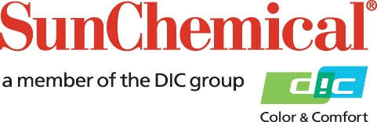

PR Contacts:
Sirah Awan/Greg Mills
AD Communications
+44 (0) 1372 464470
sawan@adcomms.co.uk
gmills@adcomms.co.uk

Sun Chemical to promote complete range of functional, industrial and graphic inks for plastics at K 2019

Wexham Springs, UK – 15 October 2019 – Sun Chemical and its German screen printing division, Coates Screen Inks GmbH, will showcase its comprehensive portfolio of specialty inks for numerous functional, industrial and graphic applications on stand C63-01, hall 4 at K 2019, which takes place from 16th to 23rd October in Dusseldorf Germany.

The showcase will emphasise the diverse range of screen, pad and specialty inks available for numerous plastic and rubber applications, from inks for food compliant packaging, to functional automotive inks, protective coatings and high tech graphics. Located in the ESMA Pavilion, Sun Chemical will illustrate its market knowledge and capabilities for automotive / high tech, plastic decoration, pad printing, functional print and printed electronics by demonstrating its products for these and other sectors including:

• SunHytek for automotive and high tech applications
• SunPad for pad printing
• SunCarte for laminated plastic cards
• SunPromo graphic inks for plastic applications
• SunPoly plastic container inks

Robin McMillan, Product Manager - Business Development Manager – Narrow Web and Industrial Europe, comments: “The K show is an ideal platform for us to present our functional, industrial screen, pad and other inks for these wide and varied market sectors. K has a strong visitor audience across a number of industries for plastics and rubber applications and, following the success we saw at K 2016, it’s only natural for us to exhibit again. Our market insight and experience make us the ideal industrial ink partner and we’ll be delighted to give visitors to the Sun Chemical stand the benefit of our knowledge.”

For more information on Sun Chemical and any of its products, please visit: www.sunchemical.com

ENDS

About Sun Chemical

Sun Chemical, a member of the DIC group, is a leading producer of printing inks, coatings and supplies, pigments, polymers, liquid compounds, solid compounds, and application materials. Together with DIC, Sun Chemical has annual sales of more than $7.5 billion and over 20,000 employees supporting customers around the world.
Sun Chemical Corporation is a subsidiary of Sun Chemical Group Coöperatief U.A., the Netherlands, and is headquartered in Parsippany, New Jersey, U.S.A. For more information, please visit our Web site at www.sunchemical.com.

