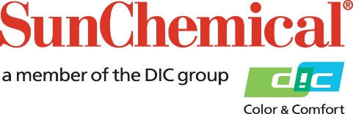

PR Contacts:
Sirah Awan/Greg Mills
AD Communications
+44 (0) 1372 464470
sawan@adcomms.co.uk
gmills@adcomms.co.uk

Sun Chemical Addresses Supply Chain Preparations Amid Coronavirus Outbreak

PARSIPPANY, N.J., U.S.A. – February 3, 2020 – Sun Chemical will continue to monitor its supply chain, including raw material and intermediate suppliers and logistics providers, amid the coronavirus outbreak.

“Proactively managing our customer orders, inventory levels, in-transit shipments and open order levels is a critical path for us,” said Jeffrey Shaw, Chief Supply Chain Officer, Sun Chemical. “We have established control teams to manage each of these areas and take the required precautions in order to prevent any supply disruptions. Specifically focusing on individual materials and suppliers will enable us to take any necessary precautions.

“At this time, our focus also includes materials from China and other high risk regions that supply to us. We will continue to keep our customers updated during this process. Bottom line, we are committed to work through this process with our customers to make sure supply disruptions are minimized.”

About Sun Chemical
Sun Chemical, a member of the DIC group, is a leading producer of printing inks, coatings and supplies, pigments, polymers, liquid compounds, solid compounds, and application materials. Together with DIC, Sun Chemical has annual sales of more than $7.5 billion and over 20,000 employees supporting customers around the world.
Sun Chemical Corporation is a subsidiary of Sun Chemical Group Coöperatief U.A., the Netherlands, and is headquartered in Parsippany, New Jersey, U.S.A. For more information, please visit our Web site at www.sunchemical.com.

