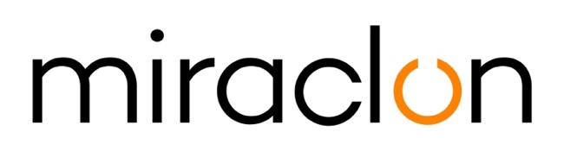

Press Release

Media Contact:
Miraclon: Elni Van Rensburg - +1 830 317 0950 – elni.vanrensburg@miraclon.com
Michael Grass – +44 (0)1372 460545 – mgrass@adcomms.co.uk

April 23rd, 2020

Miraclon receives FTA Technical Innovation Award for
KODAK FLEXCEL NX Ultra Solution featuring KODAK Ultra Clean Technology

Miraclon, the home of KODAK FLEXCEL Solutions, this week received the coveted FTA Technical Innovation Award for its KODAK FLEXCEL NX Ultra Solution, reflecting a fresh and novel approach to aqueous flexo plate making technology. As one of two overall winners in the Prepress – Graphics category and the sole plate technology winner, the award signifies the potential of the FLEXCEL NX Ultra Solution to have a significant impact on the flexo market.

Joe Tuccitto, Director of Education at FTA, says: “Recipients of the FTA Technical Innovation Award are chosen by a panel of industry experts representing all areas of the flexo industry to have the potential to positively change the future of flexography. Once again this year, the overall judging process was extremely competitive with a variety of distinctive products and innovative technologies that utilize the flexographic process or have been designed specifically to enhance flexographic printing.”

The Awards presentation took place at the commencement of this week’s 2020 FTA Virtual FORUM, with the formal in-person ceremony now scheduled to take place during the FTA Fall Conference. In 2009, shortly after its commercial introduction, the FTA recognized the KODAK FLEXCEL NX System with a Technical Innovation Award. And, as predicted by the judging panel, this technology has helped to change the capabilities of the modern flexo process over the last decade. This second FTA Innovation Award for the KODAK FLEXCEL NX Ultra Solution featuring KODAK Ultra Clean Technology is confirmation of Miraclon’s commitment to ongoing value-driven innovation for FLEXCEL NX customers.

“It is a great honor to receive this FTA Technical Innovation Award. The FLEXCEL NX Ultra Solution provides packaging printers with another method for producing high-performing FLEXCEL NX Plates,” said Dr Zaki Ali, Chief Technology Officer, Miraclon. “An aqueous plate making system with patented KODAK Ultra Clean Technology, the FLEXCEL NX Ultra Solution allows for the preparation of a press-ready plate in under one hour while removing the hurdles and challenges that have plagued aqueous platemaking solutions for the last 25 years.”

The FLEXCEL NX Ultra Solution is the first aqueous solution that provides consistent, high-performing flexo plates in a high volume, low maintenance environment, enabling printers to take advantage of all the proven print performance benefits of FLEXCEL NX Plates without the hassle of solvent processing.

Dr Ali and his R&D staff, based in Oakdale, Minnesota, have been permanent fixtures of the team behind KODAK FLEXCEL Solutions’ innovation from the early development of the FLEXCEL NX System. With a long string of patents to their name that protect the unique proprietary technology that has helped to transform the capabilities of flexo printing, Dr Ali himself is affectionately known as the ‘grandfather of NX’. The prolific team were recently awarded their 4th US patent associated with the FLEXCEL NX Ultra Solution.

ENDS

About Miraclon
KODAK FLEXCEL Solutions have helped transform flexographic printing over the last decade. Brought to life by Miraclon, KODAK FLEXCEL Solutions – including the industry-leading FLEXCEL NX and FLEXCEL NX Ultra Systems – give customers higher quality, improved cost efficiency, better productivity and best-in-class results. With a focus on pioneering image science, innovation, and collaboration with industry partners and customers, Miraclon is committed to the future of flexo and is positioned to lead the charge.
Find out more at www.miraclon.com. Follow us on twitter @kodakflexcel and connect with us on LinkedIn; Miraclon Corporation.

