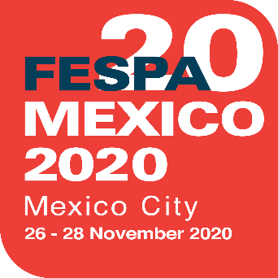
MEDIA ADVISORY
5 May 2020

FESPA MEXICO 2020 POSTPONED TO NOVEMBER
FESPA has today announced that it has taken the decision to postpone FESPA Mexico 2020, which was originally scheduled to take place on 24 - 26 September 2020. The exhibition, which is being hosted at the Centro Citibanamex in Mexico City, will now return on 26 – 28 November 2020.
The decision to postpone the event was taken following considered discussion with FESPA’s partners and the Centro Citibanamex exhibition centre, in light of the ongoing disruption caused by the COVID-19 outbreak worldwide.
FESPA CEO, Neil Felton comments: “We have been working closely with our local team in Mexico to monitor the situation throughout the COVID-19 outbreak, as we have with our other international exhibitions. The decision to re-schedule is in the best interest of the health and wellbeing of all our partners, exhibitors and visitors.”
Felton continues, “We are enthused to be returning with the event in November and sincerely look forward to welcoming all of our participants back to the Centro Citibanamex in Mexico City to celebrate the Mexican and Latin American specialty print community”.
For more information on the event and for those who have not yet registered, please visit: https://mexico.fespa.com/en

ENDS

About FESPA
Founded in 1962, FESPA is a global federation of Associations for the screen printing, digital printing and textile printing community. FESPA’s dual aim is to promote screen printing and digital imaging and to share knowledge about screen and digital printing with its members across the world, helping them to grow their businesses and learn about the latest developments in their fast growing industries.

FESPA Profit for Purpose
The shareholders are the industry. FESPA has invested millions of Euros into the global printing community over the last seven years, supporting the growth of the market. For more information visit www.fespa.com

FESPA Print Census
The FESPA Print Census is a global research project to understand the wide format, screen and digital print community. It is the largest data gathering project of its kind.

Forthcoming FESPA events include:
- FESPA Brasil, 23 – 25 September 2020, Expo Center Norte, São Paulo, Brazil
- FESPA Global Print Expo, 6 – 8 October 2020, IFEMA, Madrid, Spain
- European Sign Expo, 6 – 8 October 2020, IFEMA, Madrid, Spain
- Sportswear Pro, 6 – 8 October 2020, IFEMA, Madrid, Spain
- FESPA Mexico, 26 – 28 November 2020, Centro Citibanamex, Mexico City
- FESPA Global Print Expo, 18-21 May 2021, Messe München, Munich, Germany
- European Sign Expo, 18-21 May 2021, Messe München, Munich, Germany

Issued on behalf of FESPA by AD Communications

For further information, please contact:

Michael Grass/Imogen Woods Neil Felton
AD Communications FESPA
Tel: + 44 (0) 1372 464470 Tel: +44 (0) 1737 240788
Email: mgrass@adcomms.co.uk
iwoods@adcomms.co.uk

