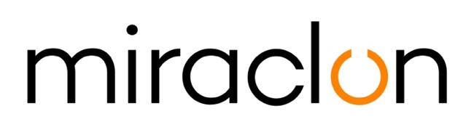

Press Release

Media Contacts:
Miraclon – pr@miraclon.com
Michael Grass – +44 (0)1372 460545 – mgrass@adcomms.co.uk

June 4th, 2020

Miraclon’s partnership with Phoenix Technologies set to drive growth in the Persian Gulf region

Miraclon is expanding its global presence through a new partnership with Phoenix Technologies, one of the Persian Gulf region’s leading technology solutions providers for the print and packaging industries. Based in Dubai, Phoenix will act as Miraclon’s local distributor partner serving a host of Arab states, including Bahrain, Kuwait, Oman, Qatar, Saudi Arabia and the United Arab Emirates.

Founded in 2007 by Afsal Kottal, Phoenix Technologies specializes in supplying print businesses with cutting edge technologies for streamlining operations, such as MIS, color management tools, as well as productivity monitoring and enhancement solutions. Today, Phoenix is the Middle East and Indian Distributor for brands such as GMG Color, X-Rite, Hybrid, Global Vision, IGT, Enfocus, Siegwerk, Arden and Ink Maker.

“The Gulf region is a large market brimming with potential for package printing and therefore one in which Miraclon has a big role to play,” explains Kris Capiau, Packaging Sales Director for Middle East, Africa, Turkey and Eastern Europe at Miraclon Corporation. “Gravure printing continues to be widely adopted in the area and our products are uniquely suited to help speed up the conversion to flexo printing. As a result, we welcome the opportunity to partner with a company that has both the sector knowledge and the large footprint to be able to drive Miraclon’s presence in the region.”

According to Afsal Kottal, Managing Director at Phoenix Technologies, the partnership between Miraclon and his company couldn’t have come at a better time. “Flexo printing is gaining momentum in the Gulf region, with more businesses investing in latest technologies and new players entering the market,” he says. “I expect this shift towards flexo printing is set to continue for the forseeable future, mainly due to shorter run lengths and reduced cost of operations, not to mention the possibilities that automation has to offer for printing presses.”

He concludes: “We believe that, with Miraclon's knowledge and solutions, we will be able to capitalize on these trends, maintaining the high quality service that our customers have come to expect from the Phoenix Technologies brand, while also helping them to further enhance their production capabilities.”

ENDS

About Miraclon
KODAK FLEXCEL Solutions have helped transform flexographic printing over the last decade. Brought to life by Miraclon, KODAK FLEXCEL Solutions – including the industry-leading FLEXCEL NX and FLEXCEL NX Ultra Systems – give customers higher quality, improved cost efficiency, better productivity and best-in-class results. With a focus on pioneering image science, innovation, and collaboration with industry partners and customers, Miraclon is committed to the future of flexo and is positioned to lead the charge.
Find out more at www.miraclon.com. Follow us on twitter @kodakflexcel and connect with us on LinkedIn; Miraclon Corporation.

