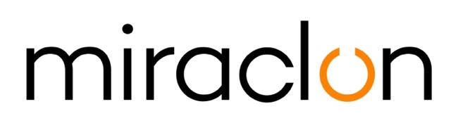
Press Release

Miraclon – pr@miraclon.com
Imogen Woods - +44 (0) 1372 464 470 – iwoods@adcomms.co.uk

June 10th, 2020

Ulrich Etiketten improves flexo quality with new
KODAK FLEXCEL NX System from Miraclon

Ulrich Etiketten, the market leader for self-adhesive labels in Austria and one of the top 10 label producers in Europe, has expanded its flexo platemaking capability with a KODAK FLEXCEL NX Mid System from Miraclon. Based in Vienna, the company employs around 200 people and caters mainly for the pharmaceutical and food industries as well as for the cosmetics and chemical sectors. The company exports approximately 30% of its work, with customers in Germany and Switzerland leading the field.
For several years now, Ulrich Etiketten has been growing faster than the Austrian label market. Its competitiveness is founded on continuous investments, and the firm has a reputation for high flexibility and reliability coupled with short delivery times. “Our aim with the FLEXCEL NX System is to deliver higher quality print plus faster turnaround times and more flexibility in meeting customer requirements,” said Managing Director Florian Ulrich when asked about his reasons for the investment. “Flexo has traditionally been our most important printing process and it always will be. Although we also do a lot of offset production on the premises, we believe that flexo – thanks to FLEXCEL NX Technology – alongside digital, is where the future lies."
The KODAK FLEXCEL NX System went into operation at Ulrich Etiketten in March 2020. It is equipped with the high-resolution option for imaging with 9600 x 4800 dpi, so that micro-text and security features can be reliably printed with the flexo plates. Rainer Ulrich, joint Managing Director, added: “Our experience with the FLEXCEL NX System so far has been excellent. It seamlessly fits into our production environment and we’ve immediately achieved a real quality leap.”

ENDS

About Miraclon
KODAK FLEXCEL Solutions have helped transform flexographic printing over the last decade. Now brought to life by Miraclon, KODAK FLEXCEL Solutions – including the industry-leading FLEXCEL NX System – give customers higher quality, improved cost efficiency, better productivity and best-in-class results. With a focus on pioneering image science, innovation, and collaboration with industry partners and customers, Miraclon is committed to the future of flexo and is positioned to lead the charge. Find out more at www.miraclon.com. Follow us on twitter @kodakflexcel and connect with us on LinkedIn; Miraclon Corporation.

