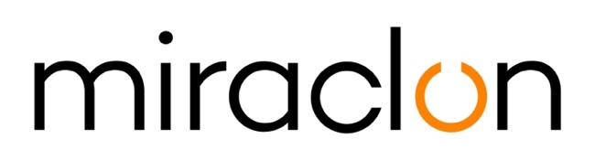

Press Release

Media Contacts:
Miraclon – pr@miraclon.com
Michael Grass – +44 (0)1372 460545 – mgrass@adcomms.co.uk

9th July, 2020

Miraclon expands presence in Pakistan through
new partnership with DigiPrint Technologies

Miraclon has partnered with DigiPrint Technologies, a Pakistani technology solutions provider for the print and packaging industries. DigiPrint, which is based in Islamabad, will be Miraclon’s local distribution partner; responsible for developing and implementing the sales and marketing of Miraclon’s products throughout Pakistan.

Founded in 2019, DigiPrint technologies specializes in the print and packaging sectors, including labels, wide web and corrugated technology. DigiPrint also represents other key brands in the market, including Vianord and Glunz & Jensen.

Kris Capiau, Packaging Sales Director for Middle East, Africa, Turkey and Eastern Europe at Miraclon Corporation comments: “Pakistan is a key growth market for flexo printing and we are seeing an increasing number of gravure jobs are being converted to flexo processes. This opens up a unique opportunity for Miraclon’s Flexcel NX solutions. With a host of existing installations of this technology already established in Pakistan, we are confident that DigiPrint will help us to offer even better support to both new and existing customers in this market.”

“With its high quality and low operational cost, we believe that the coming years will see flexo printing increase its dominance in the print and packaging industries,” says Muhammad Irfan Siddique, Managing Director of DigiPrint technologies. “Miraclon’s Flexcel NX systems are an excellent example of the many benefits of flexo technology, and sit at the forefront of this trend towards a flexo future.”

Muhammad concludes, “It is our vision to become the leading flexographic technology supplier in Pakistan. We believe that with Miraclon’s knowledge and technological solutions, we will be able to offer an even higher quality of service to our customers, enabling them to further improve their production efficiencies which, in turn, will help us to achieve that goal.”

ENDS

About Miraclon
KODAK FLEXCEL Solutions have helped transform flexographic printing over the last decade. Brought to life by Miraclon, KODAK FLEXCEL Solutions – including the industry-leading FLEXCEL NX and FLEXCEL NX Ultra Systems – give customers higher quality, improved cost efficiency, better productivity and best-in-class results. With a focus on pioneering image science, innovation, and collaboration with industry partners and customers, Miraclon is committed to the future of flexo and is positioned to lead the charge.
Find out more at www.miraclon.com. Follow us on twitter @kodakflexcel and connect with us on LinkedIn; Miraclon Corporation.

