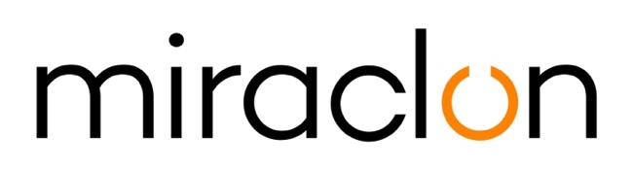

**Press Release**

Media Contact:

Miraclon: pr@miraclon.com

AD Communications: Imogen Woods - +44 (0) 1372 464470 – [iwoods@adcomms.co.uk](mailto:iwoods@adcomms.co.uk)

July 23rd, 2020

**Miraclon appoints Stephen McCartney as Commercial Director for the European, African, and Middle Eastern Region (EAMER)**

Miraclon is pleased to announce the appointment of Stephen McCartney as Commercial Director for EAMER. In his role, Stephen will manage the commercial team in the region with a focus on supporting growth in the strategic market segments for Miraclon.

Stephen joins Miraclon with over 25 years of B2B commercial and distribution management experience. Stephen comments: “Over the past year, Miraclon has seen excellent growth in the flexo printing market in EAMER, which is a credit to its experienced sales and technical support team. In my new role as Commercial Director, I am looking forward to working closely with the team, our customers and business partners to drive business growth. It is a great time to be joining the company and I am excited to be a part of its journey.”

Grant Blewett, Chief Commercial Officer, Miraclon comments: “We are pleased to welcome Stephen to our expanding team here at Miraclon. Stephen joins Miraclon as part of its sustained investment into management and talent. He will be instrumental in the implementation of all of the regional commercial growth and optimization projects in EAMER. We are confident that, with his expertise in international B2B sales and his track record of revenue growth, Stephen will be a valuable addition to our team. We would like to wish him the very best in his new role.”

ENDS

**About Miraclon**

KODAK FLEXCEL Solutions have helped transform flexographic printing over the last decade. Now brought to life by Miraclon, KODAK FLEXCEL Solutions – including the industry-leading FLEXCEL NX System – give customers higher quality, improved cost efficiency, better productivity and best-in-class results. With a focus on pioneering image science, innovation, and collaboration with industry partners and customers, Miraclon is committed to the future of flexo and is positioned to lead the charge. Find out more at [www.miraclon.com](http://www.miraclon.com). Follow us on twitter @kodakflexcel and connect with us on Linkedin; Miraclon Corporation.