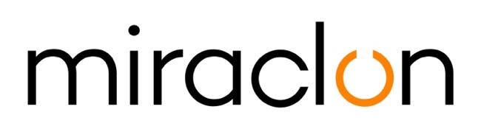

Press Release

Media Contacts:
Miraclon: Elni Van Rensburg - +1 830 317 0950 - pr@miraclon.com
AD Communications: Imogen Woods – +44 (0) 1372 464 470 – iwoods@adcomms.co.uk

15th September, 2020

Global Flexo Innovation Awards now open for entries

Miraclon today announces that the Global Flexo Innovation Awards – to honor businesses that are pioneering the transformation of the flexo industry – are open for submissions from companies wishing to be recognized for their exciting, creative and innovative commercial packaging projects printed using KODAK FLEXCEL NX Plates.

The awards, which are open to any prepress provider, printer or brand (team entries are encouraged), bring together the whole flexo community, creating opportunities to build new contacts, relationships and partnerships across the print and packaging industry. Entries will be judged by an independent panel of nine highly experienced flexo industry experts on four criteria: the degree of creativity in the graphic design of the project, conversion from other print processes to flexo, the efficiency of the company’s workflow and the level of sustainable print in the project. Entries establishing excellence in two categories will receive a silver award, in three categories a gold award and in all four categories a platinum award, demonstrating to the industry and to the winner’s customers a commitment to the highest level of print production in all aspects.

“The Global Flexo Innovation Awards is different from other competitions. It’s not about one company beating another; it’s about highlighting companies doing great work. Our goal is to demonstrate how the flexo process continues to innovate and grow, becoming more powerful as a tool,” says Christopher Horton, chair of the judging panel. “Most of the potential participants operate in the food packaging value chain, and in the current difficult environment, these companies are essential. They are working, many under difficult circumstances, to supply their product so that people can eat. While the Covid-19 crisis has been undeniably disruptive, the flexo printing value chain has played a key role in helping the world’s response. I, for one, am very much looking forward to seeing award entries displaying genuine innovations, ones with real strategic substance, which show companies driving efficient, consistent and sustainable manufacturing processes.”

Grant Blewett, Chief Commercial Officer, at Miraclon, comments: “Flexo printing has come a long way in recent years, and still has a long way to go before the real extent of its capabilities is fully recognized. We want to help celebrate the companies that are on that journey, combining flexo printing, KODAK FLEXCEL NX technology and their own innovative thinking to achieve proven outstanding results throughout the whole production process, from design, to production efficiency and commitment to sustainability.

Blewett continues: “If you’re part of a company that has been involved in flexo printing a commercial packaging project, I’d really encourage you to think about entering the Global Flexo Innovation Awards. During these difficult times, when we at Miraclon believe it’s more important than ever to celebrate the hard work and innovation taking place in our industry, we’ll ensure it’s easy for entrants to take part. And if your entry is selected by the independent judging panel for an award, you’ll become an ambassador for transformational flexographic print, gain industry-wide recognition for taking packaging print forward and have your story told across the world.”

For more information on the Global Flexo Innovation Awards and how to enter them, visit www.transformingflexo.com. To keep up-to-date with the latest news and hear from our distinguished judging panel and last year’s award winners, follow our LinkedIn and Twitter feeds.

ENDS

About Miraclon
KODAK FLEXCEL Solutions have helped transform flexographic printing over the last decade. Brought to life by Miraclon, KODAK FLEXCEL Solutions – including the industry-leading FLEXCEL NX and FLEXCEL NX Ultra Systems – give customers higher quality, improved cost efficiency, better productivity and best-in-class results. With a focus on pioneering image science, innovation, and collaboration with industry partners and customers, Miraclon is committed to the future of flexo and is positioned to lead the charge.
Find out more at www.miraclon.com. Follow us on twitter @kodakflexcel and connect with us on LinkedIn; Miraclon Corporation.

