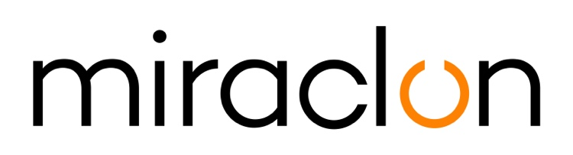
Case Study

Media Contact:
Miraclon: Elni Van Rensburg - +1 830 317 0950 – elni.vanrensburg@miraclon.com
AD Communications: Imogen Woods – iwoods@adcomms.co.uk

September 2nd, 2020

HELPING FLEXO ON THE WAY TO THE TIPPING POINT

“From a procurement perspective — and even a supply perspective — flexo is winning. When one of the really large brands switches to flexo, the world will shift.”

Andrew Hewitson, co-founder and business development director of UK flexo prepress house Reproflex3, is talking about an approaching tipping-point when he confidently expects the flexo process to get the recognition it deserves after a decade of technological refinements and enhancements. “The rate at which flexo is winning converts, especially from gravure, is gaining pace,” he continues. “There’s wide acceptance that flexo can do the job, particularly when it comes to sustainability, which is brand owners’ biggest concern now.”

From its base in north-east England Reproflex3 has done its share of spreading the flexo word, both geographically and technologically. Expanding overseas to reduce dependence on the intensely competitive UK market, the company has established successful presences in the UAE and India and partnerships with likeminded prepress specialists in the US and — most recently — Italy.

Award-winning
Technologically, Reproflex3 is best known for its FTA award-winning ProjectBlue® solution, launched in 2016. Based on the groundbreaking Kodak FLEXCEL NX System, ProjectBlue® optimizes ink delivery and image consistency by linking superior color separations, differentiated screening, patented plate patterning and specially designed aniloxes. The combination delivers outstandingly vibrant and consistent ultra-high definition output, produced at maximum press speeds and within a standard four-color ink palette.

ProjectBlue® also provides the technology platform for BlueEdge, the first product to result from Reproflex3’s collaboration with Z Due. Available exclusively from Z Due, BlueEdge does everything ProjectBlue® does, but has been adapted by the two partners to meet the requirements of the Italian corrugated postprint market, in which Z Due has a strong presence (Reproflex3 specializes in flexible packaging for blue-chip FMCG brands.)

Reproflex3 and Z Due owe their partnership directly to their participation in the Global Flexo Innovation Awards, introduced in 2018 to mark the 10th anniversary of the launch of the Kodak Flexcel NX System. At the Istanbul awards ceremony both companies won Gold Awards for outstanding examples flexo-printed packaging but, just as importantly, laid the foundations of their present collaboration.

Andrew Hewitson describes both companies as “artisans, in the best sense of the word. By this I mean that we both have a real enthusiasm for our craft. We both take pride in developing practical solutions. In Istanbul, we weren’t alone in this because, without exception, all the winners were true artisans. That was one of the real positives we took away from the awards.”

ProjectBlue® and BlueEdge are products of that artisan mindset. “We take technology and put our own stamp on it” is how Hewitson describes Reproflex3’s business model. He adds that key to the company’s continued growth is the idea of finding “headroom — the space where we can innovate and add value. If you don’t do that you risk becoming a commodity producer.”

The latest example of this philosophy in action — VORTEX® — is currently in beta-testing and is the subject of high hopes for both Reproflex3 and Z Due. “Vortex has enormous potential because it addresses a wider market than ProjectBlue®,” explains Hewitson. “By its very nature, ProjectBlue® isn’t for everybody. To get the best results from ProjectBlue®, the printer not only has to print at the very highest quality, with the highest consistency, but also maintain the process to the highest standard. There is a market sector for this application but not all printers are ready, but there are many more that want to start on the path towards ProjectBlue®. Vortex is for those businesses: it’s about using and adapting screening technology and a 360 advanced colour certification solution to help them increase their quality, step by step. Together with our partners, we are very excited about approaching the wider market in all regions with the VORTEX® solution soon.”

Both Reproflex3 and Z Due are in the process of deciding what to enter in the 2020 Global Flexo Innovation Awards, which are now organised by Miraclon, the new home (since 2019) of Kodak FLEXCEL Solutions. The awards are notable for “looking beyond the package” and evaluating the impact of submissions on the entire value chain. With high quality considered a precondition, the independent panel of judges — chaired this time by Christopher Horton, formerly senior vice-president of SGS — will be assessing entries against four categories of innovation excellence: creativity in graphic design; conversion from other print processes; workflow efficiency; and commitment to sustainability.

ENDS

About Miraclon
KODAK FLEXCEL Solutions have helped transform flexographic printing over the last decade. Brought to life by Miraclon, KODAK FLEXCEL Solutions – including the industry-leading FLEXCEL NX and FLEXCEL NX Ultra Systems – give customers higher quality, improved cost efficiency, better productivity and best-in-class results. With a focus on pioneering image science, innovation, and collaboration with industry partners and customers, Miraclon is committed to the future of flexo and is positioned to lead the charge.
Find out more at www.miraclon.com. Follow us on twitter @kodakflexcel and connect with us on LinkedIn; Miraclon Corporation.

