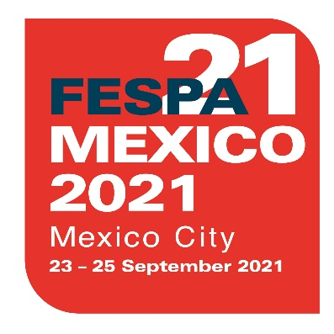
PRESS RELEASE
28 September 2020

FESPA MEXICO EXIBITION POSTPONED TO SEPTEMBER 2021
New online exhibitor showroom launched for Mexico

FESPA has today announced that FESPA Mexico 2020 will be postponed to 23 – 25 September 2021. The exhibition, which was originally scheduled to take place from 26 – 28 November 2020, will again be hosted at the Centro Citibanamex in Mexico City.
The decision to postpone the exhibition was taken in response to the ongoing business disruption and continued public health risk caused by the global COVID-19 pandemic.
Neil Felton, FESPA CEO, explains: “In May 2020, we took the decision to delay FESPA Mexico until November in the face of the developing pandemic. Since then, the impact of COVID-19 in Central America has been dynamic and uncertain. Our number one priority is the health and safety of all of our exhibitors and visitors and we are therefore taking this step to eliminate the risk to all of our participants. We look forward to welcoming our Mexican community back in September 2021.”

FESPA Mexico Exhibitor Showroom
In November 2020, in lieu of the live event, FESPA will be launching a new online Exhibitor Showroom for its Mexican speciality print community.
The digital platform will allow regional exhibitors to showcase all their latest news, product launches and videos. In addition, visitors and prospects will be able to network virtually with exhibitors to share ideas and initiate discussions on sales.
Michael Ryan, Group Exhibition Manager concludes, “We recognise the importance of hosting FESPA Mexico in educating, connecting and advancing the speciality print market in Mexico and Central America, so we’re excited to announce the exhibitor showroom. With this initiative, we’re enabling exhibitors and visitors to connect with each other, share knowledge and spark inspiration until we’re able to meet in person again in September 2021.”
For the latest updates on the FESPA Mexico exhibitor showroom visit: Mexico.fespa.com

ENDS

About FESPA
Founded in 1962, FESPA is a global federation of Associations for the screen printing, digital printing and textile printing community. FESPA’s dual aim is to promote screen printing and digital imaging and to share knowledge about screen and digital printing with its members across the world, helping them to grow their businesses and learn about the latest developments in their fast growing industries.

FESPA Profit for Purpose
The shareholders are the industry. FESPA has invested millions of Euros into the global printing community over the last seven years, supporting the growth of the market. For more information visit www.fespa.com

FESPA Print Census
The FESPA Print Census is a global research project to understand the wide format, screen and digital print community. It is the largest data gathering project of its kind.

Forthcoming FESPA events include:
- FESPA Global Print Expo, 9 – 12 March 2021, RAI, Amsterdam, Netherlands
- European Sign Expo, 9 – 12 March 2021, RAI, Amsterdam, Netherlands
- Sportswear Pro, 9 – 12 March 2021, RAI, Amsterdam, Netherlands
- FESPA Mexico, 23 – 25 September 2021, Centro Citibanamex, Mexico City

Issued on behalf of FESPA by AD Communications

For further information, please contact:

Imogen Woods Simona Jevdokimovaite
AD Communications FESPA
Tel: + 44 (0) 1372 464470 Tel: +44 (0) 1737 228 169
Email: iwoods@adcomms.co.uk Email: Simona.Jevdokimovaite@fespa.com
Website: www.adcomms.co.uk Website: www.fespa.com

