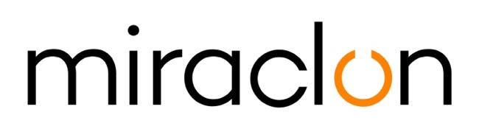

Press Release

Media Contacts:
Miraclon: Elni Van Rensburg – Tel: +1 830 317 0950 – elni.vanrensburg@miraclon.com
AD Communications: Imogen Woods – +44 (0) 1372 464 470 – iwoods@adcomms.co.uk

October 15th, 2020

Köstlin Prepress Services commits to high quality flexographic platemaking for demanding customers with the KODAK FLEXCEL NX Ultra Solution

Köstlin Prepress Services of Ditzingen, near Stuttgart in south-west Germany, recently added Miraclon’s KODAK FLEXCEL NX Ultra Solution to their range of flexo platemaking technologies for high quality packaging printing.

While Köstlin offers a broad portfolio of flexographic printing options and photopolymer sleeves, the production of KODAK FLEXCEL NX Plates accounts for 60% of all flexo plates produced. The company first began using a FLEXCEL NX Wide 4260 System in 2013 because, as Köstlin Managing Director Marc Talmon Gros puts it, “more and more of our customers were asking for FLEXCEL NX Plates.” This system has now been joined by the FLEXCEL NX Ultra Solution, which unites all of the quality and performance benefits of the well-established FLEXCEL NX System with solvent-free, VOC-free, water based processing of the flexo plates.

“FLEXCEL NX Ultra will help us systematically reduce our solvent consumption and produce plates in a more environmentally friendly way,” says Talmon Gros when prompted to comment on his firm’s reasons for investing in the new Miraclon technology. “Added to that, the FLEXCEL NX Ultra Solution will give us even more flexibility and enable our printers to get the plates much faster, which is a big advantage in many situations.”

During the few weeks since it was put into operation, Köstlin has already completed the first production runs using the KODAK FLEXCEL NX Ultra Solution in cooperation with a few selected printers with great success. Talmon Gros concludes: “Not only are our customers extremely satisfied with the achievable print quality, stability and handling capabilities of the FLEXCEL NX Ultra Plates; some are already specifying using only these plates going forward.”

The family owned business, which employs around 50 staff, specializes in repro and prepress services as well as platemaking for the most popular packaging printing processes. Established 40 years ago, Köstlin traditionally caters to packaging printers, although over the last decade international brand owners have constituted an increasingly large part of the customer base. The business portfolio is dominated by premium prepress services for flexible packaging, mainly foil and film, with more than 70% of all orders coming from the highly demanding food and cosmetics sectors.

ENDS

About Miraclon
KODAK FLEXCEL Solutions have helped transform flexographic printing over the last decade. Brought to life by Miraclon, KODAK FLEXCEL Solutions – including the industry-leading FLEXCEL NX and FLEXCEL NX Ultra Systems – give customers higher quality, improved cost efficiency, better productivity and best-in-class results. With a focus on pioneering image science, innovation, and collaboration with industry partners and customers, Miraclon is committed to the future of flexo and is positioned to lead the charge.
Find out more at www.miraclon.com. Follow us on twitter @kodakflexcel and connect with us on LinkedIn; Miraclon Corporation.

