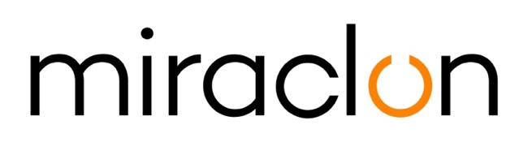

Press Release

Media Contact:
Miraclon: Elni Van Rensburg - +1 830 317 0950 – elni.vanrensburg@miraclon.com
AD Communications: Imogen Woods – +44 (0) 1372 464 470 – iwoods@adcomms.co.uk

October 29th, 2020

Dion Label sees step-change in production with KODAK FLEXCEL NX Ultra Solution investment

Dion Label has seen a step-change in their printing process since they became a Miraclon customer and installed a KODAK FLEXCEL NX Ultra Solution in June. The Westfield, Massachusetts, based labels and flexible packaging printer is now able to produce products with much greater consistency while delivering higher print quality.

Brent Berthiaume, Dion Label Prepress Manager, says: “Brands, especially pharmaceuticals, are introducing more complex designs that demand tighter registration and color tolerances. We were struggling to achieve these consistently and needed to upgrade our equipment. The quality achieved with the KODAK FLEXCEL NX plate solution had been on our radar for some time, but we wanted a non-solvent solution. As soon as the aqueous FLEXCEL NX Ultra solution became available, we quickly made the switch from our thermal system."

The Covid-19 Pandemic slowed down the installation process, but by the end of June, the new system was up and running.

He continues: “The difference in press performance since the install of the FLEXCEL NX Ultra solution has been night-and-day. The quality and color consistency we now achieve allows for much higher throughput while achieving tighter registrations along with significantly less dot gain compared to our previous system. This has all but eliminated the need for spare sets of plates on longer runs. In addition, we now run our plates consistently at a higher line screen of 175+lpi, providing our customers with the highest quality product. This line screen matches our digital presses, providing a seamless transition between the two environments."

Brent concludes: “Completely changing our plate-making system that had been in place for over 15 years was a significant risk. The KODAK FLEXCEL NX Ultra System is already proving that the risk was not only worth it, but necessary."

ENDS

About Miraclon
KODAK FLEXCEL Solutions have helped transform flexographic printing over the last decade. Brought to life by Miraclon, KODAK FLEXCEL Solutions – including the industry-leading FLEXCEL NX and FLEXCEL NX Ultra Systems – give customers higher quality, improved cost efficiency, better productivity and best-in-class results. With a focus on pioneering image science, innovation, and collaboration with industry partners and customers, Miraclon is committed to the future of flexo and is positioned to lead the charge.

Find out more at www.miraclon.com. Follow us on twitter @kodakflexcel and connect with us on LinkedIn; Miraclon Corporation.

