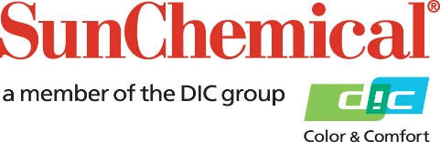

PR Contacts:
Sirah Awan/Daniel Porter
AD Communications
+44 (0) 1372 464470
sawan@adcomms.co.uk
dporter@adcomms.co.uk

Sun Chemical launches UV coating with high levels of bio-sourced and recycled material

Wexham Springs, UK – 21 April 2021 – Sun Chemical is launching SunCure® 44HC150 - a glossy stampable UV-curing coating, manufactured with 25% bio-renewable carbon content and with 12% post-consumer recycled materials. The coating has received excellent feedback following trials with existing customers and will be available throughout Europe from 15th March 2021 The launch marks a breakthrough for Sun Chemical’s energy curing line as it is the first of many such products to be rolled out featuring significant levels of bio-sourced and recycled material content.

Commenting on the new development, Mark Walkling, Product Manager, Energy Curing Packaging Products and Narrow Web Labels Europe at Sun Chemical says: “Sustainability is always at the forefront of the Sun Chemical brand in all areas of product development and our processes. One of our current key objectives is to increase the sustainability credentials of our energy-curing product line. A range of similar products will follow, including products with compostability and/or deinking certifications, as well as products that aid recycling processes both for printed paper and for printed film.

“The launch of this product aligns with Sun Chemical’s wider sustainability and circularity goals, which will help Sun Chemical to contribute to the overall recyclability of printed products. It enables us to further meet the demands of our customers and consumers in terms of reduction of carbon footprint through reusing recyclates, reducing reliance on petroleum-based materials and ultimately allowing for a more sustainable end of life.”

To find out more about SunCure® visit www.sunchemical.com/product/suncure or to find out more about Sun Chemical’s commitment to sustainable practices visit www.sunchemical.com/sustainability/.

ENDS

About Sun Chemical
Sun Chemical, a member of the DIC group, is a leading producer of printing inks, coatings and supplies, pigments, polymers, liquid compounds, solid compounds, and application materials. Together with DIC, Sun Chemical has annual sales of more than $7.5 billion and over 20,000 employees supporting customers around the world.
Sun Chemical Corporation is a subsidiary of Sun Chemical Group Coöperatief U.A., the Netherlands, and is headquartered in Parsippany, New Jersey, U.S.A. For more information, please visit our website at www.sunchemical.com or connect with us on LinkedIn or Twitter.

