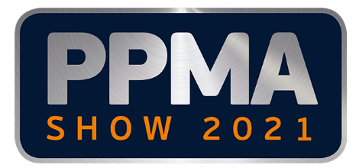
25 June 2021

Media Advisory
AD Communications appointed PR Agency for the upcoming PPMA Show

Please be advised that the PPMA Group of Associations has once again appointed AD Communications as its PR agency with responsibility for the PPMA Show 2021.

PPMA Show 2021
The PPMA Show 2021 will take place at the NEC, Birmingham from 28th to 30th September 2021.

All PR activity for the forthcoming show is now being handled by AD Communications with immediate effect.

Show information will be issued shortly. In the meantime, if you have any queries or requests for editorial material for show preview features, please contact AD Communications.

Media contacts at AD Communications:
Kirsty Jones Ellie Martin
kjones@adcomms.co.uk emartin@adcomms.co.uk
Tel: +44 (0) 1372 464470 Tel: +44 (0) 1372 464470
Mobile: +44 (0) 7714 299520 Mobile: +44 (0) 7801 525 665

Media Contacts at the PPMA:
Clare McSheaffrey
Marketing Manager
Clare.McSheaffrey@ppma.co.uk
Tel: +44 (0) 20 8773 5522

ENDS

About the PPMA
The PPMA is the UK's trade association for suppliers of processing and packaging machinery to the UK market and represents over 500 member and associate companies. Its principle objective is to promote sales of machinery, both at home and abroad, through various projects and services of mutual benefit to both members and their customers by providing free technical and machinery information and advice.

The PPMA Group of Associations includes BARA (British Automation and Robot Association) and UKIVA (UK Industrial Vision Association).

