22nd June 2021

FUJIFILM and FUJIFILM Business Innovation jointly open virtual event “FUJIFILM Virtual Exhibition 2021”

FUJIFILM and Fujifilm Business Innovation hereby announce that the graphic communication division of the two companies will hold an online event “FUJIFILM Virtual Exhibition 2021” from June 24th to July 9th. The new products will include a new print on demand system renewed under the Fujifilm brand, a new digital press in the packaging segment where high market growth is expected, and a new line up of wide format inkjet printers. The event will also feature a range of seminars from independent graphics industry experts covering a wide range of subjects, with the focus during the exhibition period on creating new value, with various topics covered including updates on industry trends and tips for overcoming the COVID-19 disaster.
< Overview of FUJIFILM Virtual Exhibition 2021 >

- Concept
Under the title of “BELIEVING IN PRINT”, Fujifilm’s “Virtual Exhibition 2021” will open as a place for printers to experience multiple solutions all designed to help create new value. Fujifilm will exhibit the latest solutions across a broad range of sectors such as commercial, package and sign & display printing in a 3D space built to reflect a “printing factory of the near future”. On show will be a variety of high quality videos of webinars and demonstrations that support the formation of growth strategies for developing new business and process reforms aimed at further efficiency.

- Registration
Registration is required to enter the Virtual Exhibition, which can be carried out at our promotional site.
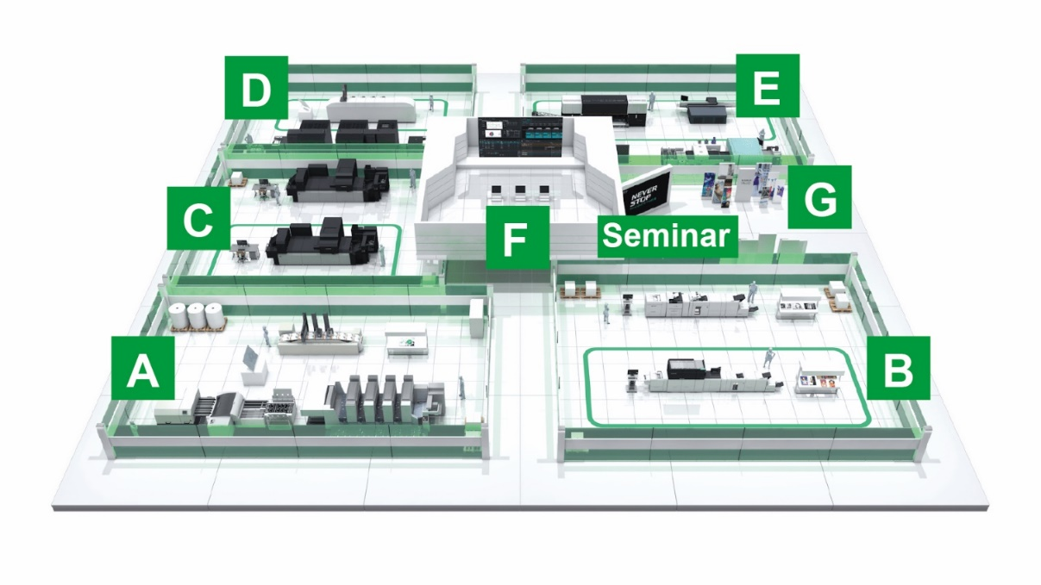
- 3D space image
A: Offset Print Line
B: Digital Print (Toner) Line
C: Digital Print (Inkjet) Line
D: Package Print Line
E: Signage Industrial Print Line
F: Workflow Solution
G: FUJIFILM Inkjet Technology

- Webinar
Fujifilm will offer eight sessions by experts from a wide range of fields in the industry which can be used to develop ideas about new printing possibilities, such as developing new businesses and growth strategies, and ideas that lead to process reforms for further efficiency.

- Keynote Session “The Graphic Arts Industry and the New Fujifilm” (24/6 14:30@CET, LIVE）
Jim Hamilton Industry Analyst, Keypoint Intelligence
Hiroaki Shimosaka General manager of Graphic Systems Business Division, Fujifilm Corporation
- “Technology driving change for variable data on direct mail and transaction print” (25/6, on demand)
Ryan McAbee Director Production Workflow Consulting Service, Keypoint Intelligence
- “Future of Digital Labels and Flexible Packaging” (25/6 16:00@CET, LIVE）
Sean Smyth Printing &Packaging Technologist, Smithers analyst &consultant, SMITHERS
- “Technology driving change for variable data on direct mail and transaction print” (25/6, on demand)
Greg Balch Vice President and General manager in charge of FUJIFILM Integrated Inkjet Solutions
Shane Tansey Business Development Manager for FUJIFILM Integrated Inkjet Solutions
Ankur Mour Mechanical Engineer III for FUJIFILM Integrated Inkjet Solutions
- “Digital Printing Value & How to Sell it” (28/6, on demand)
German Sacristan Director Production Print & Media Group, Keypoint Intelligence
- “Challenges and opportunities for commercial printers post-COVID” (28/6 16:00@CET, LIVE）
Marco Boer Vice President, IT Strategies
- “The State of Wide Format Printing 2021 – Roadmap to Recovery” (29/6, on demand)
Eric Zimmerman Director of Wide Format Printing, Keypoint Intelligence
- “A digital imprinting strategy for packaging”
Greg Balch Vice President and General manager in charge of FUJIFILM Integrated Inkjet Solutions
Shane Tansey Business Development Manager for FUJIFILM Integrated Inkjet Solutions
Jamie Walsh North American Sales Manager for FUJIFILM Integrated Inkjet Solutions

ENDS

About FUJIFILM Corporation
FUJIFILM Corporation is one of the major operating companies of FUJIFILM Holdings. Since its founding in 1934, the company has built up a wealth of advanced technologies in the field of photo imaging, and in line with its efforts to become a comprehensive healthcare company, Fujifilm is now applying these technologies to the prevention, diagnosis and treatment of diseases in the Medical and Life Science fields. Fujifilm is also expanding growth in the highly functional materials business, including flat panel display materials, and in the graphic systems and optical devices businesses.

About Fujifilm Graphic Systems
Fujifilm Graphic Systems is a stable, long term partner focussed on delivering high quality, technically advanced print solutions that help printers develop competitive advantage and grow their businesses. The company’s financial stability and unprecedented investment in R&D enable it to develop proprietary technologies for best-in-class printing. These include pre-press and pressroom solutions for offset, wide-format and digital print, as well as workflow software for print production management. Fujifilm is committed to minimising the environmental impact of its products and operations, proactively working to preserve the environment, and strives to educate printers about environmental best practice. For more information, visit www.fujifilm.eu/eu/products/graphic-systems/, or www.youtube.com/FujifilmGSEurope or follow us on @FujifilmPrint

For further information contact:

Tom Platt
AD Communications
E: tplatt@adcomms.co.uk
Tel: +44 (0)1372 460 586

