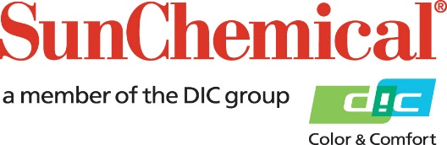

PR Contacts:
Rachelle Harry/Daniel Porter
AD Communications
+44 (0) 1372 464470
rharry@adcomms.co.uk
dporter@adcomms.co.uk

Sun Chemical Acquires SAPICI to Expand Customer Offerings in Polymers and Lamination Adhesives Market
PARSIPPANY, N.J., U.S.A. – January 10, 2022 – Sun Chemical has acquired SAPICI, a global leading company in high-performance polyurethanes for coatings, flexible packaging, industrial adhesives and more.
With SAPICI, Sun Chemical reinforces its integrated supply strategy in the packaging market by adding capabilities to develop and produce unique polymers for the entire portfolio of inks, coatings, and lamination adhesives.
The combined resources and technologies of DIC/Sun Chemical and SAPICI will provide a comprehensive and unique polymer portfolio for areas such as industrial coatings, elastomers, industrial adhesives, and sealants.
The acquisition of SAPICI will transform Sun Chemical into an integrated player in the lamination adhesives market, directly owning assets, technologies and resources to improve the product portfolio.
“Providing our customers with the most effective solutions on the market is priority number one, and the acquisition of SAPICI enables innovation in lamination adhesives to better serve this base,” said Mehran Yazdani, President, Global Packaging and Advanced Materials, Sun Chemical. “SAPICI’s core competencies in the manufacturing of ultra-low monomer isocyanates-based solutions will allow Sun Chemical to further address both current and future trends in sustainability, compliance, food contact, health and safety—reinforcing our commitment to responsible care.”
“By joining forces with industry leader Sun Chemical, our team can utilise their vast resources for the next wave of innovation in coatings, adhesives, elastomers and sealants applications, ultimately improving the products our customers rely upon daily,” said Cristian Furiosi, CEO, SAPICI. “The extensive experience and product portfolio our organisation has in this market, combined with Sun Chemical and DIC Corporation’s expertise and complementary products, provide an all-encompassing solution to excite our customers.”
To learn more about Sun Chemical’s offerings in the lamination adhesives market, visit https://www.sunchemical.com/product/sunlam.
About Sun Chemical
Sun Chemical, a member of the DIC Group, is a leading producer of packaging and graphic solutions, color and display technologies, functional products, electronic materials, and products for the automotive and healthcare industries. Together with DIC, Sun Chemical is continuously working to promote and develop sustainable solutions to exceed customer expectations and better the world around us. With combined annual sales of more than $8.5 billion and 22,000+ employees worldwide, the DIC Group companies support a diverse collection of global customers.
Sun Chemical Corporation is a subsidiary of Sun Chemical Group Coöperatief U.A., the Netherlands, and is headquartered in Parsippany, New Jersey, U.S.A. For more information, please visit our website at www.sunchemical.com or connect with us on LinkedIn or Twitter.

