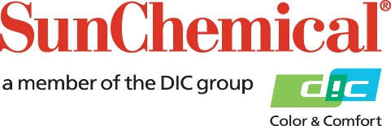

PR Contacts:
Rachelle Harry/Daniel Porter
AD Communications
+44 (0) 1372 464470
rharry@adcomms.co.uk
dporter@adcomms.co.uk

Sun Chemical to implement Energy Surcharges on Inks, Coatings, Consumables, and Adhesives in EMEA

Wexham Springs, UK – 28 February, 2022 – Sun Chemical will implement energy surcharges across its entire portfolio of packaging, commercial sheetfed, and screen inks, coatings, consumables, and adhesives in Europe, Middle East, Africa, effective from March 1st 2022.

As the unprecedented pace of inflationary cost movements continues to impact the entire spectrum of raw material and packaging components for the ink industry, without sign of stabilisation in sight, the industry is also being hit by abrupt rises of energy costs of all kinds, including electricity, gas, fuel, diesel, drastically impacting manufacturing costs and freights costs. The current situation in Europe has already been adding up further on costs, with more uncertainties moving forward.

“Sun Chemical’s priority remains to keep supplying our customers, allowing them to keep their facilities operating. We continue to leverage our global network to secure our manufacturing and services efficiency,” said Mehran Yazdani, President, Global Packaging and Advanced Materials. “However, the magnitude of recent energy related inflation cannot be absorbed and requires us to implement surcharges to our customers. The situation will need to be adjusted as it goes, and we can assure our customers that surcharges will be phasing out as the situation allows”.

Sun Chemical will communicate specific surcharges, which are in addition to previously announced price increases, directly with its customers. Customers with questions can reach out to their local Sun Chemical sales representative.

ENDS

About Sun Chemical
Sun Chemical, a member of the DIC Group, is a leading producer of packaging and graphic solutions, color and display technologies, functional products, electronic materials, and products for the automotive and healthcare industries. Together with DIC, Sun Chemical is continuously working to promote and develop sustainable solutions to exceed customer expectations and better the world around us. With combined annual sales of more than $8.5 billion and 22,000+ employees worldwide, the DIC Group companies support a diverse collection of global customers.

Sun Chemical Corporation is a subsidiary of Sun Chemical Group Coöperatief U.A., the Netherlands, and is headquartered in Parsippany, New Jersey, U.S.A. For more information, please visit our website at www.sunchemical.com or connect with us on LinkedIn, Instagram or Twitter.

