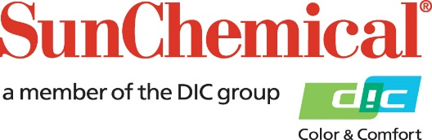

PR Contacts:
Heather Buchholz, Sun Chemical Matt Parry, Mower
+1 708 236 3779 +1 315 413 4318
heather.buchholz@sunchemical.com mparry@mower.com

Sun Chemical’s Dahej Facility Celebrates Historic Safety Record
PARSIPPANY, N.J., U.S.A. – April 5, 2022 – Sun Chemical announced that its Dahej, India manufacturing facility recently celebrated 4,500 safe days without a lost time injury (LTI).
“Safety is a cornerstone of Sun Chemical’s operational roadmap, and the Dahej facility is setting a golden standard for implementing these important safety procedures,” said Gary Andrzejewski, Corporate Vice President, Environmental Affairs, Sun Chemical. “The wellbeing of our employees is of paramount importance, and I can’t thank our team enough for living these values day in and day out.”
The Dahej plant opened in 2010 as a sheetfed ink manufacturing hub, and now manufactures sheetfed inks across the company’s portfolio.
Learn more about Sun Chemical’s sheetfed ink offerings.

About Sun Chemical
Sun Chemical, a member of the DIC Group, is a leading producer of packaging and graphic solutions, color and display technologies, functional products, electronic materials, and products for the automotive and healthcare industries. Together with DIC, Sun Chemical is continuously working to promote and develop sustainable solutions to exceed customer expectations and better the world around us. With combined annual sales of more than $8.5 billion and 22,000+ employees worldwide, the DIC Group companies support a diverse collection of global customers.
Sun Chemical Corporation is a subsidiary of Sun Chemical Group Coöperatief U.A., the Netherlands, and is headquartered in Parsippany, New Jersey, U.S.A. For more information, please visit our website at www.sunchemical.com or connect with us on LinkedIn, Instagram or Twitter.

