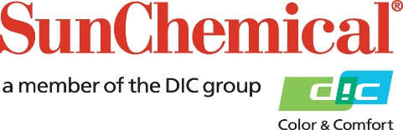

PR Contacts:
Rachelle Harry/Daniel Porter
AD Communications
+44 (0) 1372 464470
rharry@adcomms.co.uk
dporter@adcomms.co.uk

SunLam contributes to compostability of digitally produced packaging
with HP Indigo

South Normanton, UK – 7 April 2022 – Sun Chemical has collaborated with HP, Futamura and Mitsubishi Chemical to produce a compostable pack, which combines individual components (substrates, inks and adhesive) certified by leading testing organizations.

The industrial compostable pouch comprised of Futamura’s certified home and industrially compostable cellulose film, NatureFlex™ 23NK, was printed on an HP Indigo 6K digital press and laminated using Sun Chemical’s solvent-free, industrially compostable adhesive SunLam SFC100+HAC306, and Mitsubishi Chemical’s BioPBSTM FD92PM sealant film converted by Baker Labels.

The results obtained during the digital printing process, as well as the solvent-free lamination, provided comparable lamination and sealing performance to a conventional plastic-based pack.

Sun Chemical’s SunLam lamination adhesive has been certified by Germany’s DIN-Certco – a leading, global, independent certifying body for compostable products – to meet compostable standards.

All of the individual components of the laminate have been individually certified by independent bodies. However, for the full laminate (and pouch) to be fully certified, it would need to pass a disintegration test.

Marcos Valdezate, Sun Chemical Global Business Development Manager for SunEvo™ Coatings for Digital, commented: “We are pleased to be making a difference to the environment through compostable packaging collaborations, such as this one with HP Indigo, Futamura and Mitsubishi Chemical.

“We have also been working hard to develop products, such as SunLam, which meet compostable standards and will ultimately help our customers to expand their circular economy.”

ENDS

About Sun Chemical
Sun Chemical, a member of the DIC Group, is a leading producer of packaging and graphic solutions, color and display technologies, functional products, electronic materials, and products for the automotive and healthcare industries. Together with DIC, Sun Chemical is continuously working to promote and develop sustainable solutions to exceed customer expectations and better the world around us. With combined annual sales of more than $8.5 billion and 22,000+ employees worldwide, the DIC Group companies support a diverse collection of global customers.

Sun Chemical Corporation is a subsidiary of Sun Chemical Group Coöperatief U.A., the Netherlands, and is headquartered in Parsippany, New Jersey, U.S.A. For more information, please visit our website at www.sunchemical.com or connect with us on LinkedIn or Twitter.

