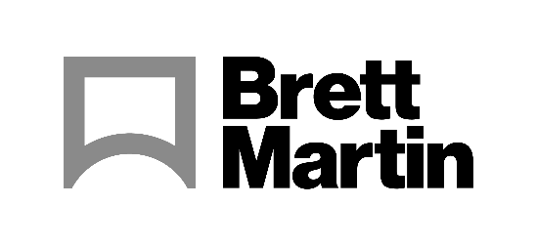

31 May 2022
Brett Martin launches sustainable Marlon BioPlus Polycarbonate sheet options
Brett Martin, the UK’s largest producer of polycarbonate sheet materials has launched new, more sustainable Marlon BioPlus Polycarbonate sheet options, which represent a quantum shift towards climate neutral plastic sheets produced from a certified mass balanced source with bio-based feedstock.
This new development is the result of Brett Martin’s partnership with Covestro, one of the World’s leading polymer producers. Their Makrolon® RE replaces 71% of the fossil based raw materials with bio-circular attributed material (via mass balance approach), e.g. from used cooking oils. In addition, a further reduction in carbon is achieved through the use of green energy in the production of the raw material.
Commenting on the development, Barbara Giershausen, Sales Manager, Covestro said: “On our journey to become fully circular, we support our industry partners in meeting their sustainability targets. With our Makrolon® RE portfolio, customers like Brett Martin have exactly the same quality and performance as fossil-based Makrolon® without the need to change existing production processes.”
Covestro adopts a mass balancing approach via ISCC PLUS (International Sustainability and Carbon Certification) to achieve the allocation of this low carbon material to Brett Martin, enabling Brett Martin to provide complete assurance to customers for the new sheet options.
The partial move away from fossil based raw materials and the benefits of providing a secondary use for the bio-circular attributed feedstock enables the process to achieve an 84% reduction in carbon footprint during the production of the Makrolon® RE. This saving is further enhanced during the extrusion of the Marlon BioPlus sheet which uses 100% renewable electricity, generated directly through Brett Martin’s own dedicated wind and solar facilities.
The mass balancing approach delivers both practicality and certified assurance for users of the Marlon BioPlus ranges in Flat, Multiwall and Corrugated polycarbonate sheet formats. This opens new doors for specifiers, processors and fabricators to choose a more sustainable polycarbonate from renewable sources and with a low carbon impact.
William Martin, Director at Brett Martin commented “The drive for sustainable, carbon neutral plastic materials is progressing well and now our introduction of Makrolon® RE from a mass balanced and certified source of bio-circular attributed feed-stock is taking this to the next level”
ENDS
About Brett Martin:
UK-based Brett Martin employs nearly 1000 people across several locations throughout the UK and Europe, and is a market leader in the manufacture of specialist plastic products for construction, roofing, engineering, print and display. The company exports over 50% of its £210 million turnover to more than 74 countries worldwide.

Further information:
Sirah Awan Gillian Fraser
AD Communications Brand Manager, Brett Martin
Tel: + 44 (0) 1372 464470 Tel: +44 (0) 28 9084 9999
Email: sawan@adcomms.co.uk Email: gillianfraser@brettmartin.com

