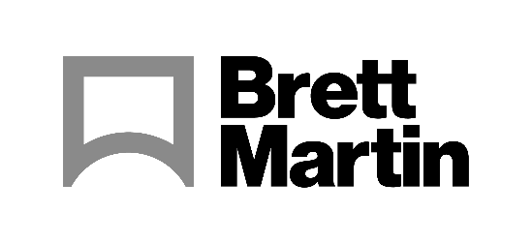

5th May 2022

Brett Martin products to feature at eurolaser international INNOVATION DAYS in Lüneburg, Germany
With the theme DIVERSE & INFINITE: Markets, Materials and Technology, eurolaser’s 2022 INNOVATION DAYS will reflect the versatility of applications and materials in modern laser processing. Brett Martin will be among the respected partners joining eurolaser for the event.
With its own exhibition space, alongside a select group of materials providers and printer manufacturers, Brett Martin will be presenting a range of its plastic sheet products – including Foamalux White and Marcryl FS, and Brett Martin’s own experts will be on hand to talk to attendees about the quality and versatility of its range.
eurolaser will be routing Brett Martin’s Foamalux White into the shape of Northern Ireland, where the company is based and then laser cutting the Brett Martin logo marque from Marcryl FS extruded acrylic. The logo will then sit in a routered groove in the map.
At this year’s event, all visitors will have the opportunity to get hands-on, being taken through a real production line process step by step until they hold a finished product, like the one above, in their hands.
Thorsten Brandt, COO and main organizer of the INNOVATION DAYS says: “This year, our INNOVATION DAYS will be more interactive than ever before. Visitors will follow the process from the starting material to the final product, and will be able to take action at crucial moments. This is not to be missed.”
“We’re delighted to have the opportunity to be part of this event,” says Duncan Smith, Sales Director at Brett Martin. “In-person events have been few and far between until very recently so it’s fantastic to have the opportunity to be involved. eurolaser is an important partner to Brett Martin and we look forward to talking with visitors about huge range of creative applications that are possible through our combined expertise.”
ENDS
About Brett Martin:
UK-based Brett Martin employs nearly 1000 people across several locations throughout the UK and Europe, and is a market leader in the manufacture of specialist plastic products for construction, roofing, engineering, print and display. The company exports over 50% of its £180 million turnover to more than 74 countries worldwide.

Further information:
Sirah Awan Gillian Fraser
AD Communications Brand Manager, Brett Martin
Tel: + 44 (0) 1372 464470 Tel: +44 (0) 28 9084 9999
Email: sawan@adcomms.co.uk Email: gillianfraser@brettmartin.com

