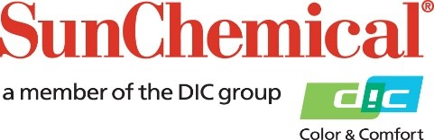

PR Contacts:
Rachelle Harry
AD Communications
+44 (0) 1372 464470
rharry@adcomms.co.uk

Sun Chemical to Increase Prices and Surcharges on Inks, Coatings, Consumables, and Adhesives in EMEA to Address Unprecedented Inflation of Utilities/Energy and Labour Costs

October 3rd 2022 – Sun Chemical will increase prices effective immediately across its entire portfolio of packaging, commercial sheetfed, and screen inks, coatings, consumables, and adhesives in Europe, Middle East, Africa, effective October 1st 2022.
The current geopolitical situation in Europe continues to upset the unprecedented inflationary trends further, with severe impact onto operating costs, including utilities and labour costs, through the entire supply chain. Sun Chemical continues to strive for finding ways of mitigating these costs, but the magnitude and speed of cost increases requires the company to further increase prices.
“Sun Chemical’s priority has been to keep supplying our customers, allowing them to keep their facilities operating” said Mehran Yazdani, President, Global Packaging and Advanced Materials. “Sun Chemical’s global reach has helped secure the sourcing of raw materials and maintain production, however, the costs to secure those materials, manufacture our products, and deliver them to our customers have continued escalating to a level that requires us to raise further prices and surcharges effective immediately for all products, so that we can continue ensuring a steady flow of our quality products to customers. Without signs of stabilisation so far, the situation will need to be adjusted as it goes, and no price guarantee can therefore be given for any period”.

To learn more about Sun Chemical’s sustainable solutions visit www.sunchemical.com/sustainability

ENDS

About Sun Chemical
Sun Chemical, a member of the DIC Group, is a leading producer of packaging and graphic solutions, color and display technologies, functional products, electronic materials, and products for the automotive and healthcare industries. Together with DIC, Sun Chemical is continuously working to promote and develop sustainable solutions to exceed customer expectations and better the world around us. With combined annual sales of more than $8.5 billion and 22,000+ employees worldwide, the DIC Group companies support a diverse collection of global customers.

Sun Chemical Corporation is a subsidiary of Sun Chemical Group Coöperatief U.A., the Netherlands, and is headquartered in Parsippany, New Jersey, U.S.A. For more information, please visit our website at www.sunchemical.com or connect with us on LinkedIn, Instagram or Twitter.

