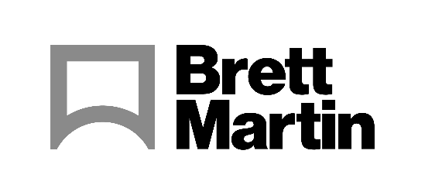

02 November 2022

Colex Finishing Solutions joins Brett Martin’s Approved Partner programme after successful collaboration at PRINTING United 2022
Brett Martin is pleased to announce that Colex Finishing Solutions has become its latest Approved Partner following a successful collaboration at PRINTING United 2022 in Las Vegas. Paying homage to the casinos that surround the Las Vegas Convention Center, Colex used Brett Martin’s Foamalux Xtra foam PVC in 6mm to create a dice design on its Sharpcut Pro cutting and routing equipment at the show.
Colex specializes in wide format cutting equipment for Graphic Sign, Display, P.O.P. and Packaging. During the PRINTING United show, the Sharpcut Pro range of cutters were put through their paces, with the Router performing outstanding with the Foamalux Xtra, first routing a design into the foam PVC and then routing the through cut to complete the final piece.
Keith Verkem, Colex Finishing Solution’s Senior Product Manager, explains the importance of the collaboration, “When we demonstrate our equipment at exhibitions or to potential customers at Colex’s Demo Facility in Elmwood Park, NJ. It is important that the substrate used is consistent in order to produce the same quality of cut on every sheet. That consistency is achieved from Brett Martin media. Colex Finishing is now able to share cut profiles for the Brett Martin range of products which ensures the cut will be right the first time and every time.”
The companies’ collaboration is part of Brett Martin’s Approved Partner Programme. The Northern Ireland based plastics manufacturer works closely with cutting, printing and thermoforming machine manufacturers to test and showcase the processing capabilities of its semi-finished product portfolio.
Mark Robinson, Brett Martin’s Sales Manager for the USA and Canada, explains, “It is important for us to work alongside companies such as Colex. We need to ensure that our products can be successfully processed on the equipment which our customers use. Through these collaborations, we can ensure that our products are continuously evolving and performing to the highest standards and kept up to date with the latest technology advances.”
For more information about Brett Martin’s products visit www.brettmartin.com. For more information about Colex Finishing Solutions’ range of cutters visit www.colex.com.
ENDS

Notes for Editors
About Brett Martin:
UK-based Brett Martin employs nearly 1000 people across several locations throughout the UK and Europe, and is a market leader in the manufacture of specialist plastic products for print and display, construction, roofing and engineering. The company exports over 50% of its £210 million turnover to more than 70 countries worldwide.
About Colex:
Colex Finishing, Inc, headquartered in Elmwood Park, New Jersey specializes in wide format cutting equipment for Graphic Sign, Display, P.O.P. and Packaging. Established in 1972, Colex offers the industry’s most extensive line of precision cutting equipment together with premier service.
Colex offers full service always paying attention to our customer’s needs. “Affordability Meets Productivity” is our motto. Our products and services are guaranteed to deliver the productivity and reliability essential to our customers’ success.

