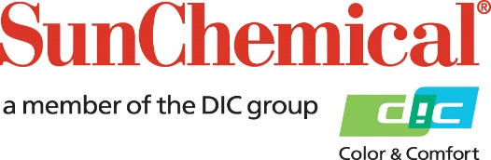

PR Contacts:
Heather Buchholz, Sun Chemical Rayyan Rabbani, AD Communications, UK
+1 708 236 3779 +44 (0)7827 910 382
heather.buchholz@sunchemical.com rrabbani@adcomms.co.uk

Sun Chemical will present its latest solutions for printed electronics and biosensors at LOPEC 2023

SOUTH NORMANTON, UK – 9 February 2023 – At LOPEC 2023 (Munich, 28 February – 2 March, Booth B0.305), Sun Chemical will present its expanded portfolio of material solutions for printed electronics and biosensor applications. The broad range of conductive and dielectric ink technologies deliver the performance and reliability required in high-tech markets, such as automotive, aerospace, home electronics, consumer electronics, and medical.

For printed electronics, the SunTronic product line now includes high-resolution silver conductive ink for transparent metal-mesh based capacitive switches, LED-curable dielectric inks, as well as silver, carbon and dielectric inks for in-mold structural electronics and stretchable sensor applications.

Sun Chemical’s SunSens biosensor products and solutions include a broad range of functional materials, which are tailor-designed for the printed electro-chemical sensors used in health diagnostics, and environmental and agricultural monitoring.

Tony Searle, Electronic Materials Business Director at Sun Chemical, comments: “LOPEC conference is one of the key printed electronics events in the world. As a committed corporate member of the OE-A organization, we welcome the opportunity to present our latest product developments, share technology insights and network with the influential industry community at LOPEC 2023.”

Underlining the company’s expertise in electronics materials and applications, Sun Chemical’s Global Technology Manager for Electronic Materials, Dr. Erika Rebrosova was invited to give an intensive short-course on the morning of February 28th on the topic of “Inks for Printed Electronics Applications”.

Dr. Rebrosova is responsible for leading new product development and technology support for applications in printed electronics, biosensors, printed circuit boards, and photovoltaics. She has been working on ink and coating technologies for electronics applications for over 15 years and has co-authored multiple technical publications. Learn more about her conference presentation.

SunChemical, SunSens, and SunTronic are either trademarks or registered trademarks of Sun Chemical Corporation in the United States and/or other countries

About Sun Chemical
Sun Chemical, a member of the DIC Group, is a leading producer of packaging and graphic solutions, color and display technologies, functional products, electronic materials, and products for the automotive and healthcare industries. Together with DIC, Sun Chemical is continuously working to promote and develop sustainable solutions to exceed customer expectations and better the world around us. With combined annual sales of more than $8.5 billion and 22,000+ employees worldwide, the DIC Group companies support a diverse collection of global customers.

Sun Chemical Corporation is a subsidiary of Sun Chemical Group Coöperatief U.A., the Netherlands, and is headquartered in Parsippany, New Jersey, U.S.A. For more information, please visit our website at www.sunchemical.com or connect with us on LinkedIn, or Instagram.

