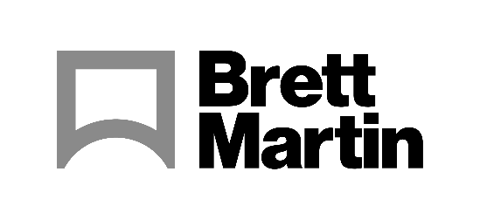

16th March 2023

Brett Martin announces partnership with Keencut
The collaboration will be showcased on the Soyang Europe stand at Sign & Digital UK
Brett Martin today announces its newest approved partner, Keencut – a UK-based manufacturers of specialist cutting equipment for sign-making use. Brett Martin and Keencut will be collaborating for the first time at Sign & Digital (21-23 March 2023, NEC, Birmingham, UK), on Soyang Europe’s stand (G10). Soyang Europe is a well-respected wide format materials and hardware supplier.
Keencut will be cutting Brett Martin’s 10mm Foamalux Light, Foamalux Eco and 3mm Marcryl acrylic, using Keencut’s SteelTrak cutter and Evolution3™ SmartFold cutter, after the materials are printed using a Fujifilm Acuity Prime printer.
Specifically formulated for digital printing, Foamalux Light is bright white in colour, and combined with a flat even surface, print quality is fully optimized for clarity, allowing for outstanding results. Additionally, Foamalux Eco has up to 80% reclaimed post-production waste content, reducing landfill and making it a greener choice of foam PVC – while still possessing all the printability benefits of the Foamalux range.
Debbie Pendergrast, Business Development Manager, Keencut says: “Keencut’s collaboration with Brett Martin allows us to show customers how amazing materials like Foamalux and Marcryl can be perfectly cut and finished using Keencut's precision cutters. Combining superior materials with the cutting power and accuracy of the Keencut Evolution3™ and SteelTrak allows sign makers to improve quality and productivity.
“It’s important to carry out these tests, and the approved partnerships programme is a great way to ensure both our cutters and Brett Martin’s substrates are going to continue to provide the best results with top quality.”
Brett Martin and Keencut’s collaboration is part of Brett Martin’s Approved Partner programme. The Northern Ireland based plastics manufacturer works closely with cutting, printing and thermoforming machine manufacturers to test and showcase the processing capabilities of its semi-finished product portfolio.
“We’re delighted to be expanding our approved partners programme yet again, partnering with Keencut.” says Nick Hughes, UK Sales Manager at Brett Martin. “Through such collaborations, we can ensure that our products are continuously evolving and performing to the highest standards. Our Approved Partners programme guarantees that our customers minimise product wastage and maximise output from the very outset by eliminating the need for costly and time-consuming trials and test runs. Keencut’s products demonstrate reliability, productivity and value, making them an ideal partner to demonstrate the quality of our substrates to the sign and display industry at Sign & Display UK – a key UK show for the Sign & Display industry.”
To learn more, or to speak to a Brett Martin representative, visit the Soyang stand (G10) at Sign & Digital UK.
ENDS
About Brett Martin:
UK-based Brett Martin employs over 1000 people across several locations throughout the UK and Europe, and is a market leader in the manufacture of specialist plastic products for construction, roofing, engineering, print and display. The company exports over 50% of its £210 million turnover to more than 74 countries worldwide.

Further information:
Sirah Awan
AD Communications
Tel: + 44 (0) 1372 464470
Email: sawan@adcomms.co.uk

