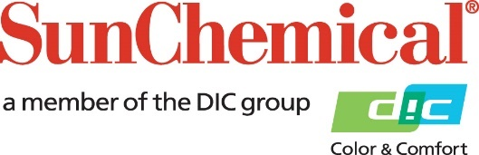

PR Contacts:
Heather Buchholz, Sun Chemical Sirah Awan, AD Communications, UK
+1 708 236 3779 +44 (0) 1372 460542
heather.buchholz@sunchemical.com sawan@adcomms.co.uk

Sun Chemical Receives Silver Rating for Sustainability from EcoVadis

South Normanton, U.K. – July 18, 2023 – Sun Chemical received a silver rating for its sustainability efforts across all business units and regions from EcoVadis, the world’s largest provider of business sustainability ratings.

The silver rating places Sun Chemical in the top 25 percent of rated companies within its business sector and was earned through EcoVadis’ assessment in four categories—environment, ethics, labor and human rights, and sustainable procurement.

“Recognition from EcoVadis is an exciting milestone in Sun Chemical’s journey toward sustainability,” said Mike Simoni, Global Sustainability Director, Sun Chemical. “This award is a strong reflection of our dedication to improving eco-efficiency and providing industry advancements in sustainability as we work with DIC Corporation toward our goal of carbon neutrality by 2050.”

The silver rating is evidence of the ongoing efficacy of Sun Chemical’s comprehensive sustainability initiatives which are organised into the three pillars of sustainable operations, collaborative sustainability initiatives, and sustainable products and services.

Sun Chemical’s holistic sustainability initiatives consider both upstream and downstream environmental impacts. Using its ‘5R framework’ of Reuse, Reduce, Renew, Recycle, and Redesign as a guide, Sun Chemical has made operational and technological developments to reduce carbon footprint, conserve virgin resources, and minimise waste. This approach positions Sun Chemical as a leader in sustainable business practices and solutions across the inks, pigments, coatings, and adhesives industries.

Recognised globally as the most trusted provider of business sustainability ratings, EcoVadis has rated over 100,000 companies based on the incorporation of sustainability and corporate social responsibility into their businesses. Comprising over 200 categories in 175 countries, the EcoVadis rating method utilises global sustainability standards, including the Global Reporting Initiative, the United Nations Global Compact, and the ISO 26000 Social Responsibility Standard.

To learn more about Sun Chemical’s approach to sustainability and to download its latest Sustainability Report, click here.

About Sun Chemical
Sun Chemical, a member of the DIC Group, is a leading producer of packaging and graphic solutions, colour and display technologies, functional products, electronic materials, and products for the automotive and healthcare industries. Together with DIC, Sun Chemical is continuously working to promote and develop sustainable solutions to exceed customer expectations and better the world around us. With combined annual sales of more than $8.5 billion and 22,000+ employees worldwide, the DIC Group companies support a diverse collection of global customers.

Sun Chemical Corporation is a subsidiary of Sun Chemical Group Coöperatief U.A., the Netherlands, and is headquartered in Parsippany, New Jersey, U.S.A. For more information, please visit our website at www.sunchemical.com or connect with us on LinkedIn or Instagram.

