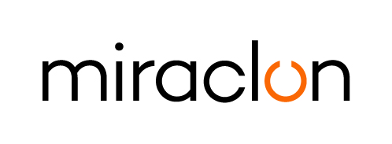
Photo Caption

Media Contacts:
Elni Van Rensburg – +1 830 317 0950 – elni.vanrensburg@miraclon.com
Josie Fellows – +44 (0)1372 464470 – jfellows@adcomms.co.uk

August 23, 2023

FlexoColor successfully completes Miraclon Certification Program for flexographic platemaking

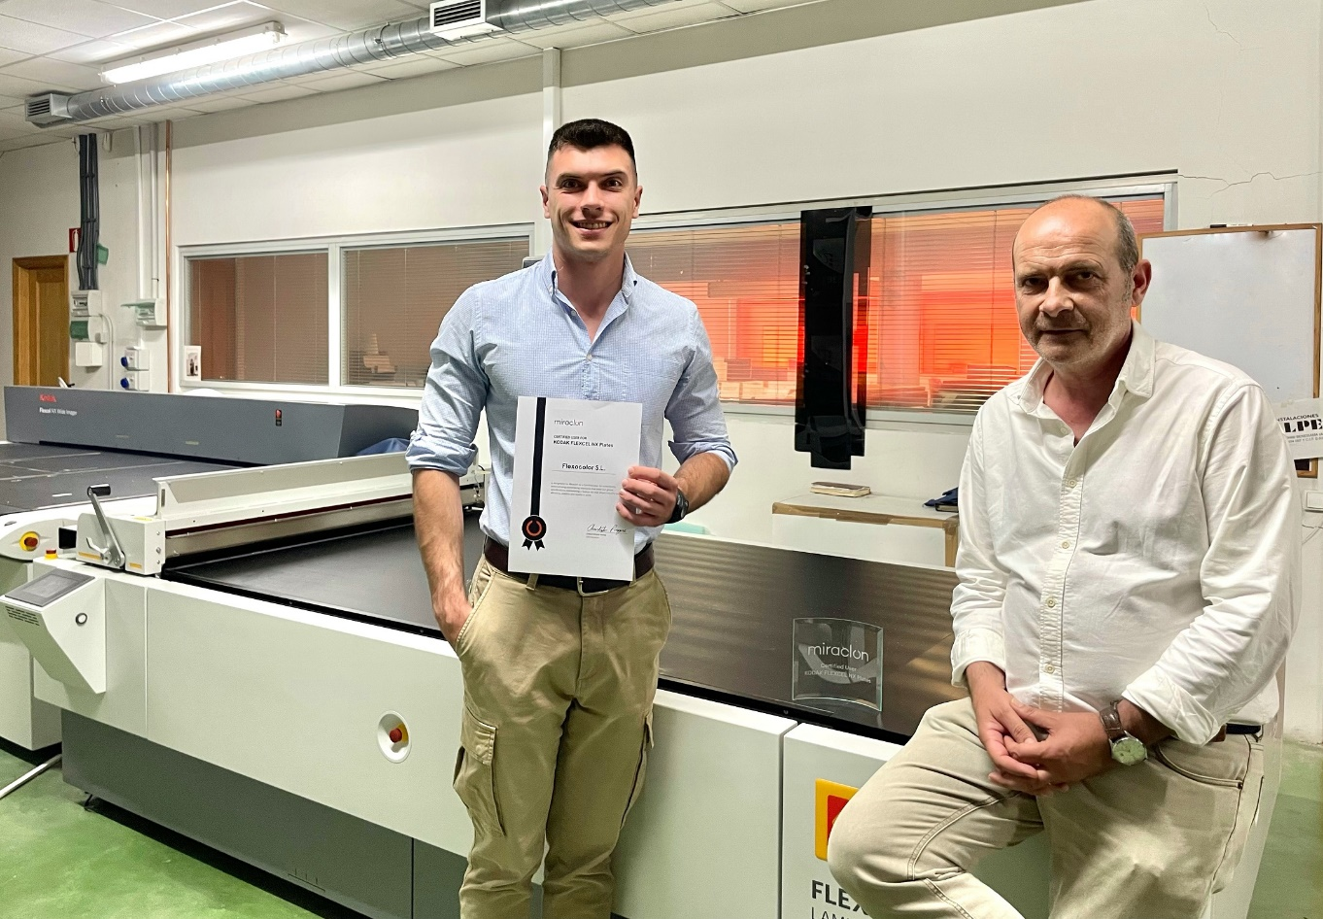
José Vicente Belda, Quality Manager (L) and Vicenta Belda, Owner (R)

FlexoColor, based in Valencia, Spain, has successfully completed the Miraclon Certification Program for FLEXCEL NX Plates. The certification has been designed to evaluate KODAK FLEXCEL System users’ ability to meet international standards in flexographic platemaking and represents a feature set that drives industry-leading efficiency, repeatability, and consistent quality flexo plate production. The certification process is also supported with comprehensive data measurement and analysis.

“Our customers come to us for excellence, and the high international standards set by the Miraclon Certification Program for FLEXCEL NX Plates underscores that excellence is exactly what they get,” says Jose Vicente Belda Azorin, Quality Manager at FlexoColor.

“The certification also serves as guarantee that we are working with the very best materials and equipment on the market to deliver the high quality our customers expect.”

ENDS

About Miraclon
Miraclon is the home of KODAK FLEXCEL Solutions, which have helped transform flexographic printing for more than a decade. The technology, including the industry-leading FLEXCEL NX and FLEXCEL NX Ultra Systems, and FLEXCEL NX Print Suite that enables PureFlexo™ Printing, maximizes on-press efficiency, delivers higher quality and overall best-in-class results. With a focus on pioneering image science, innovation, and collaboration with industry partners and customers, Miraclon is committed to the future of flexo and continues to be positioned to lead the charge. Find out more at www.miraclon.com, and follow us on LinkedIn and YouTube.

