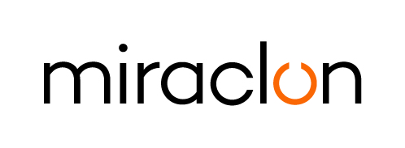
Press Release

Media Contact:
Elni Van Rensburg – +1 830 317 0950 – elni.vanrensburg@miraclon.com
AD Communications: Josie Fellows – +44 (0)1372 464470 – jfellows@adcomms.co.uk

August 17th, 2023

Miraclon partners with Printman to drive growth in Romania

Miraclon today announces its new partnership with Printman, one of Romania’s largest printing technologies and consumables providers. Headquartered in Otopeni, with two additional branches around the country in Cluj and Iasi, the company will serve as the local channel partner for Miraclon and will be responsible for developing and implementing sales, marketing, and technical and service support for KODAK FLEXCEL NX Solutions in Romania.

The new partnership sees Printman expanding its presence in the flexo printing market. Jozsef Bugar, Sales Manager Printman, said: “Flexo printing is a widely adopted printing technology in the local packaging industry and is known for its versatility, cost-effectiveness, and ability to produce high quality applications – even in long print runs. Miraclon offers the best prepress technology to address industry needs, with FLEXCEL NX Technology pushing the boundaries of the efficiency, productivity and precision levels that can be achieved with flexo.”

Jozsef Bugar adds: “In discussions with trade shops and converters, accuracy, repeatability, the ability to print on sustainable substrates, optimization of the platemaking process, print quality and job turnaround times are key considerations when they invest in new technology. This, together with sustainable printing as one of the key trends we’re seeing in Romania, makes FLEXCEL NX Technology the perfect candidate for anyone looking to address these challenges and concerns.”

Kris Sentek, Sales Manager for Central-Eastern Europe at Miraclon comments, “Eastern Europe continues to be a key growth market for flexo printing, with a host of opportunities for trade shops and converters to take advantage of FLEXCEL NX Technology to maximize productivity, efficiency, and sustainability targets, and ultimately improve their bottom line. The Printman team has excellent technical knowledge and strong customer relationships, and I’m confident that both existing and prospective customers in the region will benefit from their expertise.”

ENDS

About Printman
Find out more about Printman at www.printman.eu, and follow them on LinkedIn, YouTube and Facebook.

About Miraclon
Miraclon is the home of KODAK FLEXCEL Solutions, which have helped transform flexographic printing for more than a decade. The technology, including the industry-leading FLEXCEL NX and FLEXCEL NX Ultra Systems, and FLEXCEL NX Print Suite that enables PureFlexo™ Printing, maximizes on-press efficiency, delivers higher quality and overall best-in-class results. With a focus on pioneering image science, innovation, and collaboration with industry partners and customers, Miraclon is committed to the future of flexo and continues to be positioned to lead the charge. Find out more at www.miraclon.com, and follow us on LinkedIn and YouTube.

