August 24, 2023

DIC Releases HYDRAN™ GP Series of Environment-Friendly Waterborne Polyurethane Resins
—Help reduce greenhouse gas emissions and VOCs, and deliver
a performance comparable to solvent-based products—

Tokyo, Japan—DIC Corporation today announced the release of the HYDRAN™ GP series of environment-friendly waterborne polyurethane resins. These new resins have a higher solid content than conventional water-based polyurethane resins and contain no amines, helping customers to shorten process times and lessen odors, as well as to reduce greenhouse gas emissions and volatile organic compounds (VOCs). These resins deliver an outstanding performance that is comparable to that of solvent-based products, previously seen as difficult for waterborne polyurethane resins. The HYDRAN™ GP series is available globally and is suitable for a range of applications including artificial leather, coatings and adhesives.

Product page: https://www.dic-global.com/en/products/polyurethane/green-wpu/

Background to Development
Polyurethane resins boast excellent properties, including flexibility, strength and resistance to abrasion, chemicals and light. Owing to the tightening of environmental regulations in the People’s Republic of China (PRC), Europe and elsewhere, and to growing awareness of the Sustainable Development Goals (SDGs), needs for waterborne resins that do not contain organic solvents and thus have no adverse effects on human health or the environment are rising worldwide. However, conventional waterborne polyurethane resins have underperformed their solvent-based counterparts in terms of, among others, texture, flexibility, hydrolysis resistance and storage stability, and have also had problems with odor caused by the amines they contain.

Product Overview
To address the multiple issues associated with conventional waterborne polyurethane resins, DIC developed the HYDRAN™ GP series of waterborne polyurethane resins with a quality that is on a par with that of solvent-based polyurethane resins. While this product is environment-friendly and waterborne, it does not contain odor-causing amines, so it reduces both unpleasant smells and VOCs during processing and in finished products. Moreover, by increasing the resin concentration from 35%–50% to 50%–60% and lowering water content, greenhouse gas emissions from raw materials procurement through to the production of finished products can be as much as 60% less than with solvent-based polyurethane resins.
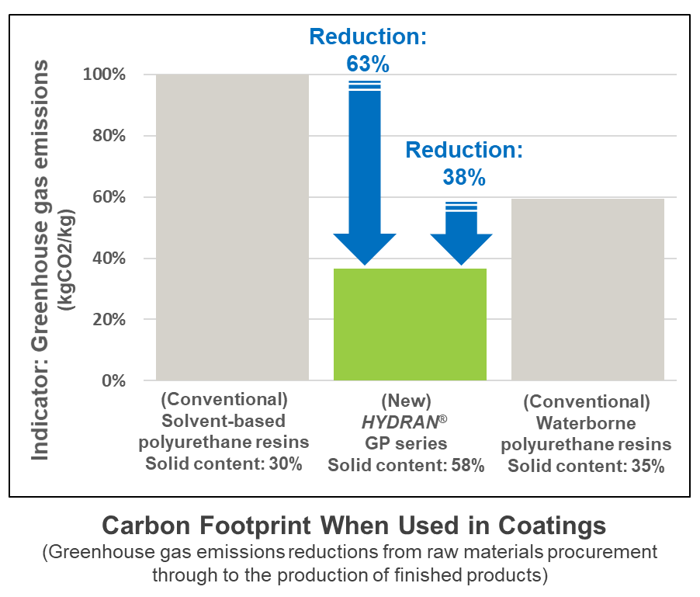

Note: Figures are derived from internal calculations based on ISO 14040 and ISO 14044. (Because these are trial calculations made using a method developed by DIC, findings may change in the future.)

In the DIC Vision 2030 long-term management plan, DIC sets forth a basic strategy of expanding the Functional Products business with a focus on sustainable products. The DIC Group will continue working to accelerate development and bolster sales of such products, including waterborne and biomass resins, by capitalizing on its long history, as well as its wealth of expertise and technical capabilities, in the production of synthetic resins.

– Ends –

For more information, please contact the Corporate Communications Department of DIC Corporation at +81-3-6733-3033 or dic-press@ma.dic.co.jp. Customer inquiries should be addressed to the Performance Material Products Division’s N Project at dic-gwpu@ma.dic.co.jp

