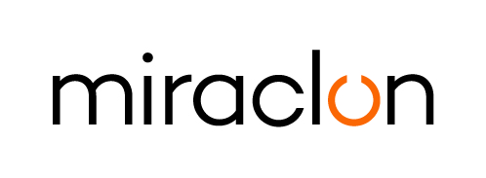
Press Release

Media Contact:
Kathy Higgins – +1 612 226 8028 – kathleen.higgins@miraclon.com
Josie Fellows – +44 (0)1372 464470 – jfellows@adcomms.co.uk

September 26, 2023

Miraclon partners with El Kassab to drive rapid growth of flexo in Egypt

Miraclon today announces its new partnership with Elkassab Foreign Trade Co., part of the El Kassab Group. As its new channel partner in Egypt, the company will be responsible for developing and implementing sales, marketing and technical support services for KODAK FLEXCEL NX Solutions in the rapidly growing flexo market.

The new partnership is also a strong strategic move for El Kassab as the local industry is seeing a sharp rise in flexo printing, according to Walid Soufi, Business Unit Director, El Kassab. “As one of the biggest countries in Africa, Egypt produces a large percentage of all packaging for brands across the continent and even further afield. Up to now, brands have chosen gravure for the quality it delivers, but as they look at alternative options due to shorter runs, sustainability targets and the need for faster turnarounds, FLEXCEL NX Technology allows them to consider and choose flexo printing as a viable alternative.”

Kris Capiau, Sales Manager for Middle East, Africa and Turkey at Miraclon adds: “Egypt is proving to be a key growth market for flexo printing, with a host of opportunities for trade shops and converters to take advantage of FLEXCEL NX Technology. The El Kassab team is well placed to maximize opportunities in the region with their technical knowledge and strong customer relationships, and I’m confident that both existing and prospective customers will benefit from their expertise.”

ENDS

About Miraclon
Miraclon is the home of KODAK FLEXCEL Solutions, which have helped transform flexographic printing for more than a decade. The technology, including the industry-leading FLEXCEL NX and FLEXCEL NX Ultra Systems, and FLEXCEL NX Print Suite that enables PureFlexo™ Printing, maximizes on-press efficiency, delivers higher quality and overall best-in-class results. With a focus on pioneering image science, innovation, and collaboration with industry partners and customers, Miraclon is committed to the future of flexo and continues to be positioned to lead the charge. Find out more at www.miraclon.com, and follow us on LinkedIn and YouTube.

